Cross Country
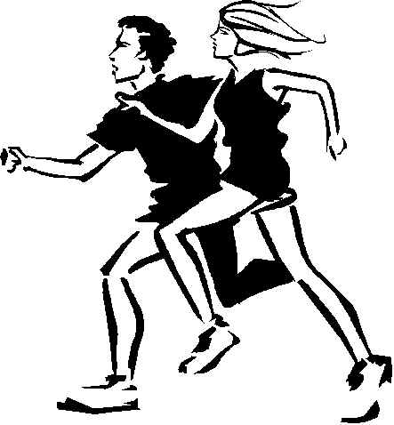
In September our cross-country teams took part in the East and Central Manchester cross-country championship at Chorlton Park. It was a huge event with nearly 300 children taking part.
Winner!
Incredibly, Victoria (one of our Year 6 team) won the girls’ race. This is the first time one of our children has won the cross-country race. What an achievement!
There were strong performances from all our girls and they managed to finish 2nd in the race, just 3 points behind Cavendish; this means the girls have qualified for the City finals in November.
The boys also ran very well and finished 5th in the boys’ race.
Well done to both our teams.

