Champions !
St Richard’s are the Manchester handball champions!
On 11th October we took 2 teams to the Manchester Handball City finals at Parrs Wood. One team performed well and won 2 and lost 2 of their games and narrowly went out at the group stage.
The second team won all 6 of their games and were crowned champions of Manchester. The 3 boys and girls each received a gold medal and the school were presented with an impressive trophy to keep.
This is the first time a St Richard’s team have become Manchester Champions.

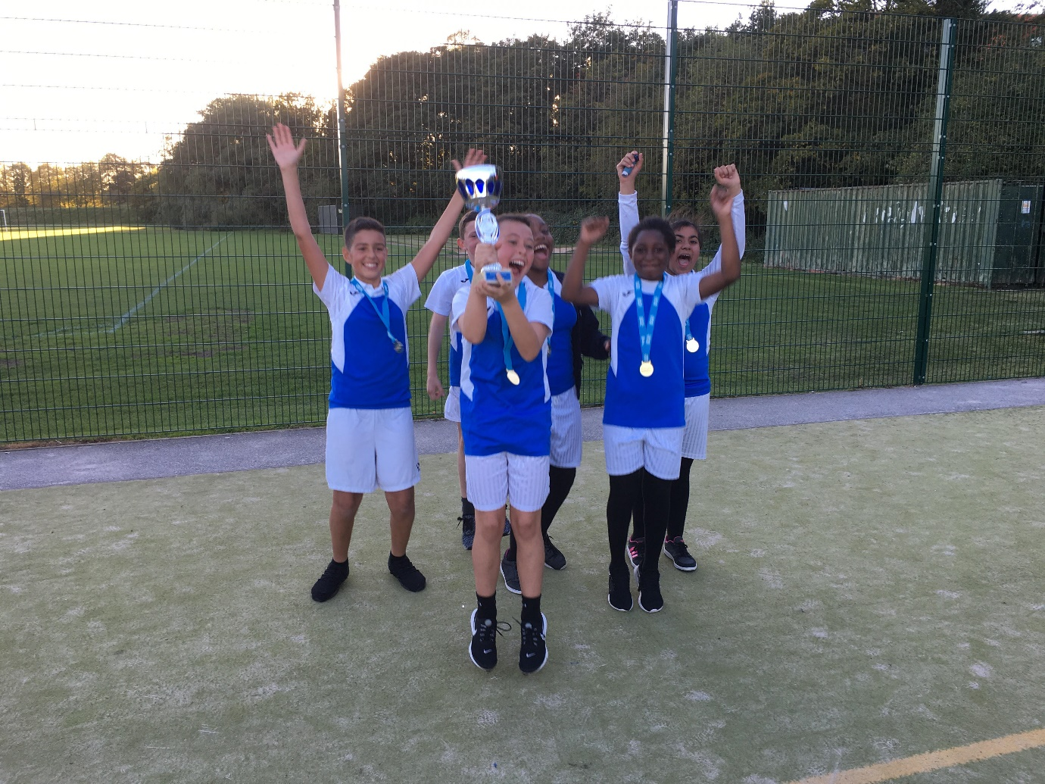
Girls’ Football
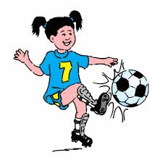
Our girls’ football team were in action on October 15th in the second round of matches in the girls’ football league at Parrs Wood. Again the girls’ played really well and won 4 of their 5 games. They are at present in 2nd place in the table of 12 teams.

Boys’ Football
On 11th October the boys played their first game of the season at St Barnabas in Openshaw. In a very exciting game the boys came away with a 3-3 draw. Tyler scored 2 and Corey 1. A solid start to the season.

