Intra-School Sport
At the end of every half-term, in games lessons there are house competitions in the sport for that half-term; for this half-term the sport was cricket and there were many exciting tournaments.
Here are 2 examples:
Class 11
‘This term, we have had a lesson on cricket for P.E. To finish for half term, we had a cricket tournament in our houses, my team being St. Luke. First, we played determinedly against St. John and when we received our results, we were overjoyed. We had got the same score, 13, but because one of our teammates had caught the ball we won with 15 points. Then, we had the finals, versus the winners of the other match, St. Mark. They had really good players, but we won by a lot, St. Mark’s earning 18 points and us winning with 29 points! Our team was so happy and I will always remember that experience.’
Neelofer
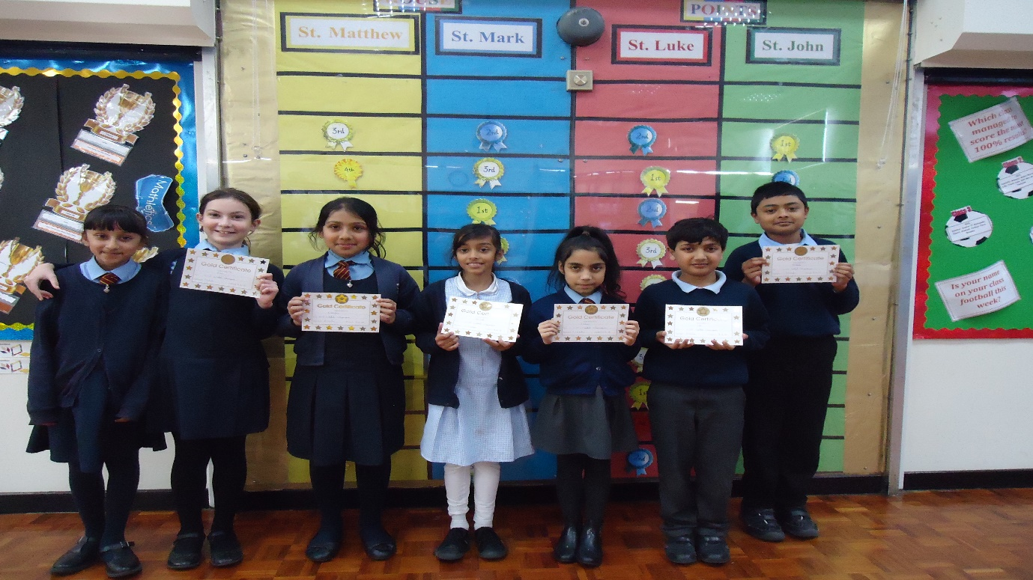
Class 8 Winners; St Luke
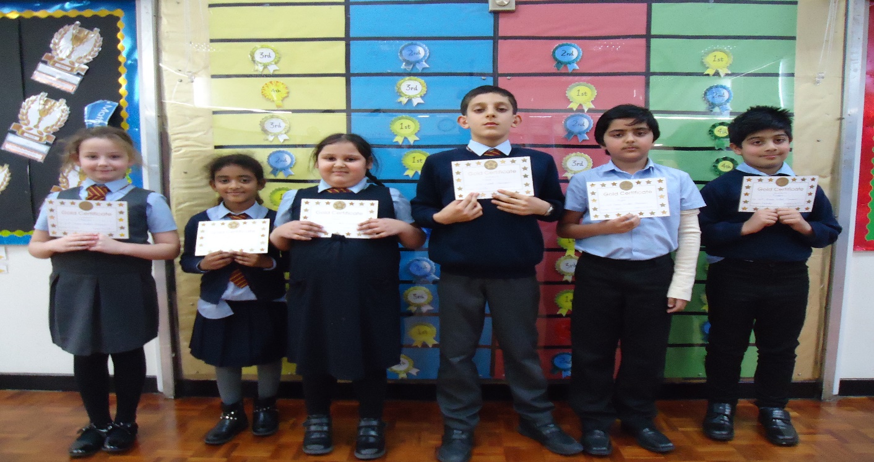
Global Day
To celebrate Global Day, Thursday’s games lessons were given over to a Cricket World Cup tournament. Four of the best teams in the world – England, Pakistan, Australia and South Africa (one from each continent) battled it out in each class to be crowned world champions. The children loved their exciting contests.
The winners were:
Class 12: Australia
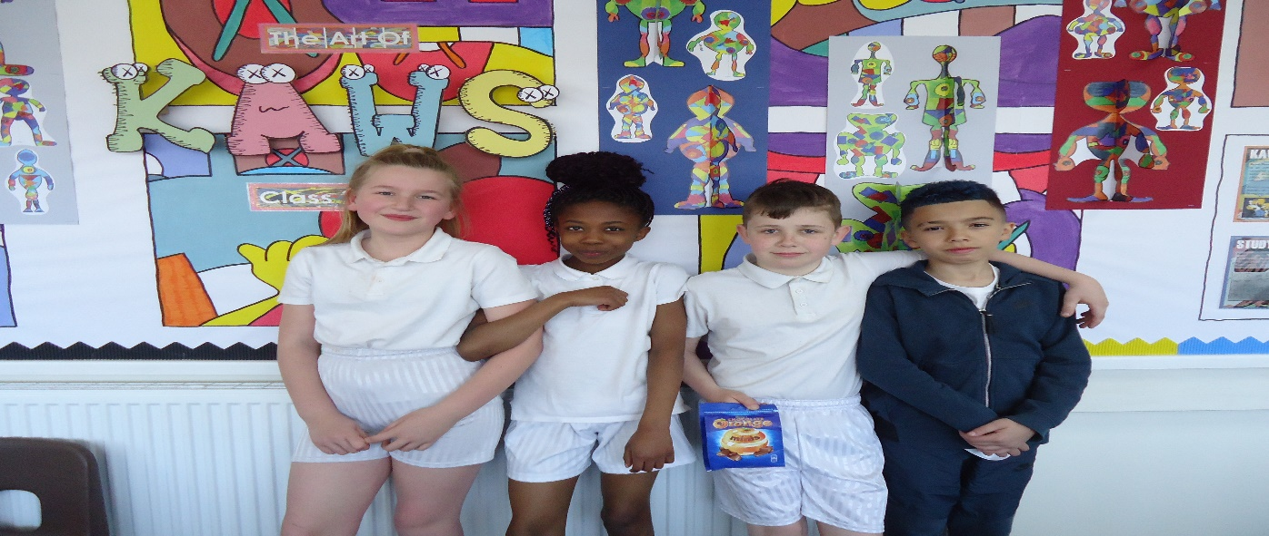
Class 13: South Africa
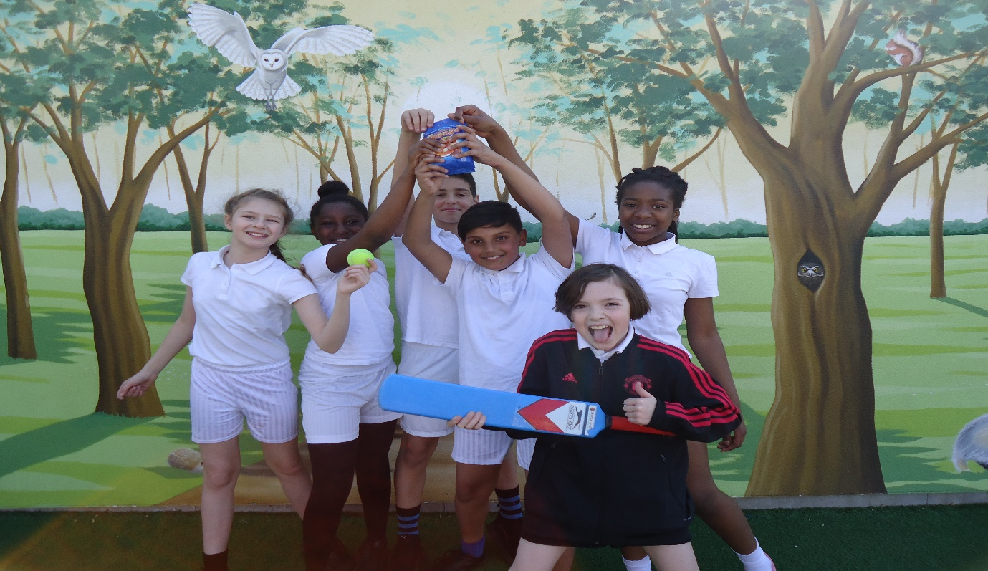

Class 14: Australia

