St. Richard’s R.C Primary School  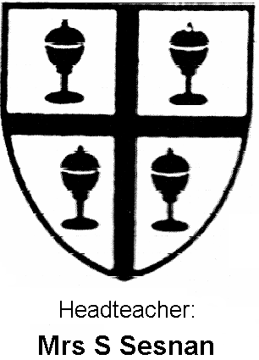 |  | Year One- class 1 and 2  Summer
Literacy | This term we will be thinking about traditional fairy-tales. We will explore plots, characters and vocabulary linked to them. We will re-write fairy-tales, write from the perspective of a character and create our own versions using ICT. We shall be working on our grammar and punctuation skills.
Mathematics | This term we will be concentrating on mental strategies in mathematics. We will be adding and subtracting mentally, concentrating on place value and using this to help us sequence numbers correctly. We will be developing our multiplication and division skills.
Science | This term we will be completing our topic on plants. We will be identifying specific garden plants, labelling the parts of the plant and what they are used for and learning about the importance of bees and pollination. We will plant our own seeds and learn how to look after them.
ICT | This term we shall be looking at how we can programme simple devices and create moving pictures. We shall use Comic-life to create our own fairy-tale comics and use cameras to record our animations.
RE | We will be looking at different holidays and holydays that happen throughout the year. We will also be looking at reconciliation and how to say sorry to other people. We shall read and explore Bible stories and relate them to our own lives.
Music | The children will be concentrating on rhythm and pulse using their voices and instruments.
PSHE | This term we shall be looking at ways in which we can solve problems. We shall explore how we can resolve issues with our friends and peers. We will also look at how we are part of a community.
Geography | This term we shall be monitoring closely the weather and making comparisons to winter weather. Hopefully we will be able to report back that there is some summer sun coming!
Art | This term we will be concentrating on drawing and painting still life. We will be looking at the work of Paul Cezanne, Van Gogh and Claude Monet. We will also be looking at the impact of pop art and art nouveau over the centuries.
D&T | This term we shall be looking at the importance of healthy eating and we will learn how to use cutlery carefully and correctly to make some fruit kebabs.
PE | During games we shall be working on our team games, developing throwing and catching skills and learning about the importance of being a member of the team. In dance we will be using our body to express different moods and using low to the ground and tall movements to do this. In gymnastics, we will be thinking of imaginative ways that we can jump, roll and travel using the apparatus.
Other events/ celebrations | St-George’s Day celebrations  Earth day  Father’s day  Ramadan

