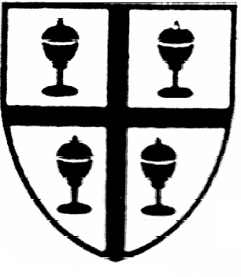  St. Richard’s R.C Primary School |  | Year Two  Summer One
RE | Caritas in Action: Helping each other to make the right choices.  R.E: Pentecost – the children will look at the story of Pentecost and how they can use their gifts from Holy Spirit. We will then explore one of the other world religions.
Mathematics | The children will recap their understanding of the four operations and will then apply this to a variety of problems and challenges. We will begin by looking at shape; lines of symmetry, right angles, sorting shapes and properties of shape. Then we shall explore statistics and data collection. The children will learn about different measures and how they can be used. The children will then revise all topics in preparation for their SATs.
Literacy | This half term we will be studying the Katie Morag stories (linked to Geography). We will learn about the maps and keys. We will study where places are and how we can plan routes. We will use ICT to find maps and direct Beebots.
Science | This term we will finish learning about plants. We will then study humans and other animals where will learn about how to keep healthy and fit.
ICT | This term we shall be looking at how we can programme simple devices and create moving pictures. We shall use Comic-life to create our stories and cameras to record our own models.
Music | We will continue to work with our music teacher; Mrs Matson.  We will have our weekly recorder lessons on a Monday.
PSHE | This term we shall be celebrating St. George’s Day and learning about how we can eat healthy and keep active.
Geography | We shall learn about maps and study the Isle of Struay based on the Katie Morag stories.
Art | The children will continue to explore different artists and will try to recreate their iconic artwork. The children will also learn about collaging and how to join materials together.
PE | During games we shall be working on our team games. We shall consider how we can work effectively as a team. In Gymnastics we will continue to use the equipment to develop our core skills.
Other events/ celebrations | Caritas in Action Day- Happiness and Fairness  St. George’s Day

