PE News 13.09.19
School Games Mark Gold
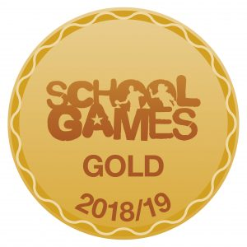
In July, the school received confirmation that we have achieved the School Games Mark Gold for the first time. This is a great achievement for our school and is a fitting reward for all the hard work put in by everyone in our school community – children, parents and teachers.

Cross-Country
Our cross-country team took part in the East Manchester Championships on Tuesday 10th September at Chorlton Park. The children ran with great determination and enjoyment. Results will follow after next week’s event.

After School Sports Clubs
Due to the school’s 50th Anniversary celebrations, clubs will not begin until the week beginning 30.09.19. A full timetable will follow.

