PE News 22.01.20
Boys’ Football
Our Year 6 boys’ 6 aside football team took part in the Manchester United Primary School’s 6 aside competition on Tuesday 14th January at the Cliff training ground. The standard was exceptionally high and the boys only managed to win 1 of their 8 games. However, as always their behaviour and commitment were exemplary and they were a great credit to the school.
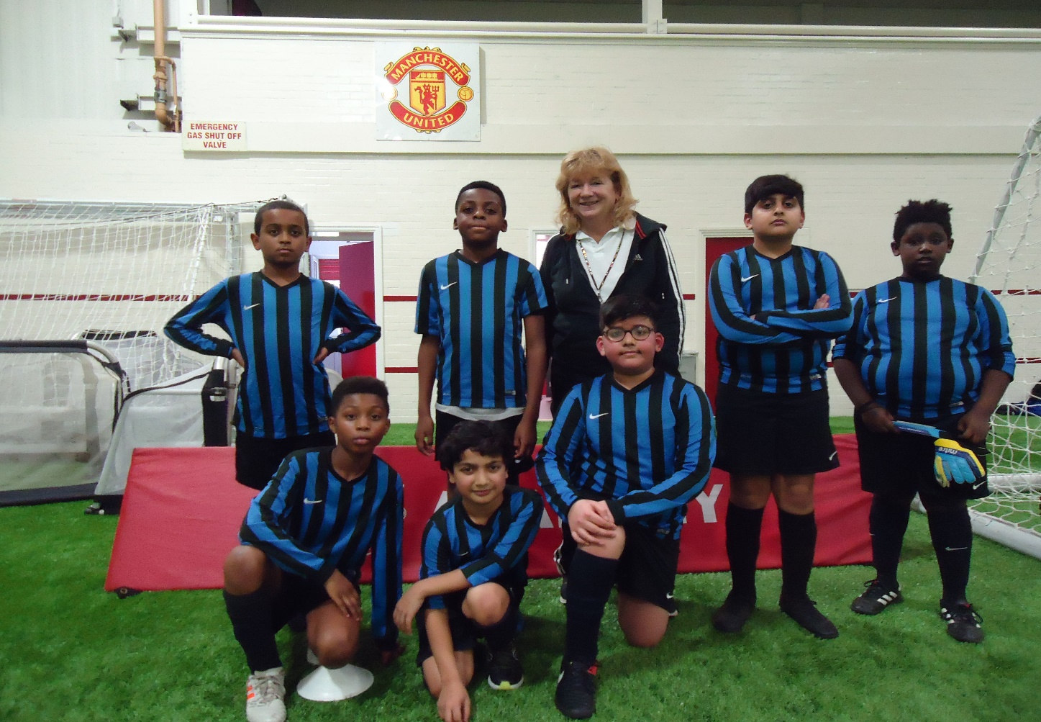

Basketball
One of our basketball teams was in action on Tuesday 21st January in the East Manchester competition at Belle Vue. They showed off their shooting skills and played 4 exciting games, drawing 2 and narrowly losing 2 and finishing a creditable 3rd on the evening.
Adam won a special award for the School Games value of Passion.
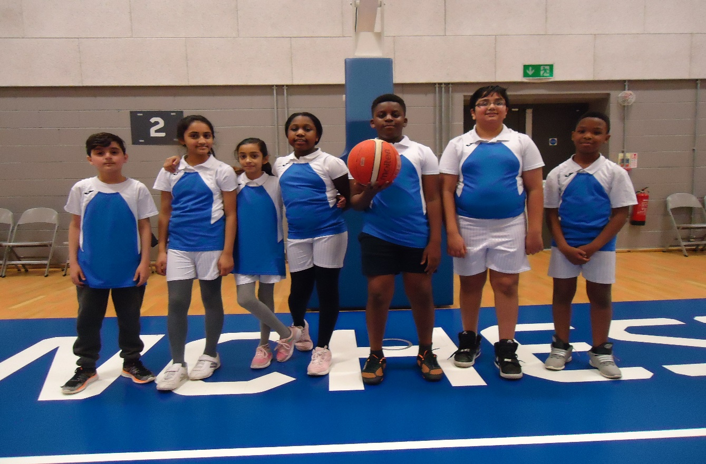

After School Sports Clubs
The Active Schools Club on Tuesdays for Yr3/4 is break dancing: starting on 14th Jan. 2020 and finishing on 4th February 2020.
Due to the dark winter nights and the inclement weather there will be no football club after school on Mondays next half-term. It will resume in February.

