**Home Learning for Year 1 pupils from 20th- 1st May 2020**

St. Richard’s R.C. Primary School

**[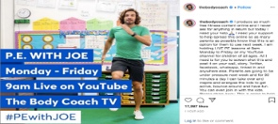](https://www.youtube.com/watch?v=Rz0go1pTda8)CLICK THE IMAGES TO VISIT THE LINKED WEBSITES**



[This Photo](http://guiastematicas.bibliotecas.uc.cl/c.php?g=697915&p=4951594) by Unknown Author is licensed under [CC BY-NC-ND](https://creativecommons.org/licenses/by-nc-nd/3.0/)

**Start your day with some exercise – tune in to PE with JOE WICKS at 9.00am.**

Remember we are still focusing on the time of Easter. The coming Sundays (19th & 26th April) are called the second and third Sundays of Easter. Learn about the Gospel story for Sunday26th April, where some of Jesus’ friends made a journey on the road to Emmaus (Luke 24:13-35).

Watch this ‘Surprising Story’ video on YouTube, then use what you have learned to retell the story to your families through writing and illustrations. Talk to your families about the meaning behind this Gospel story.

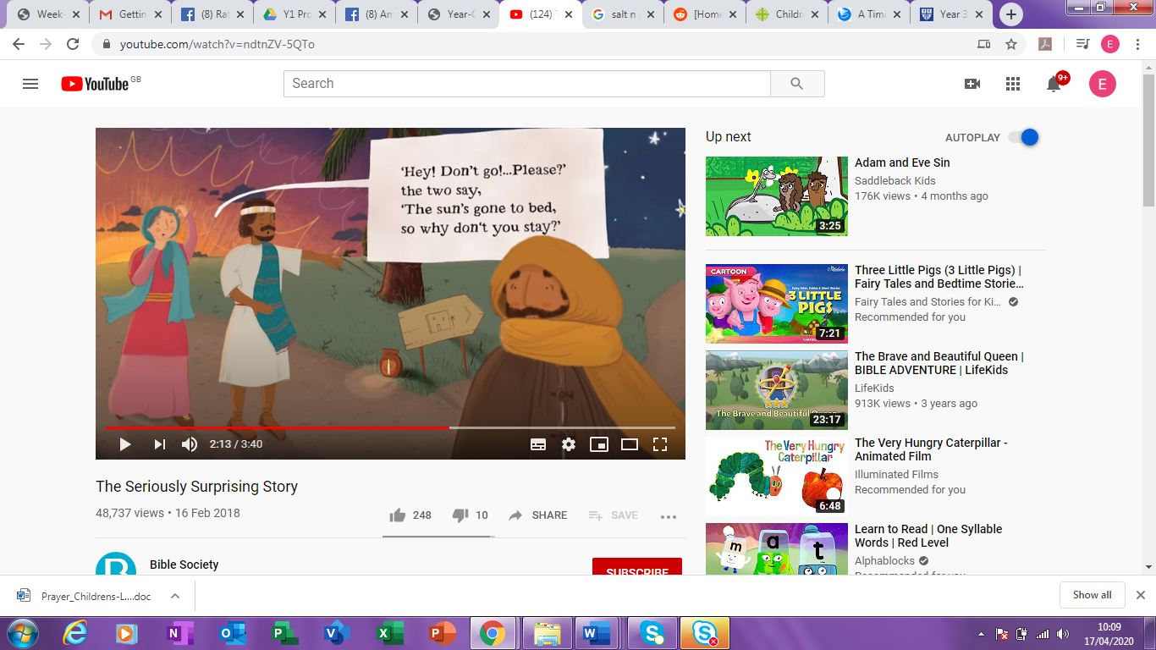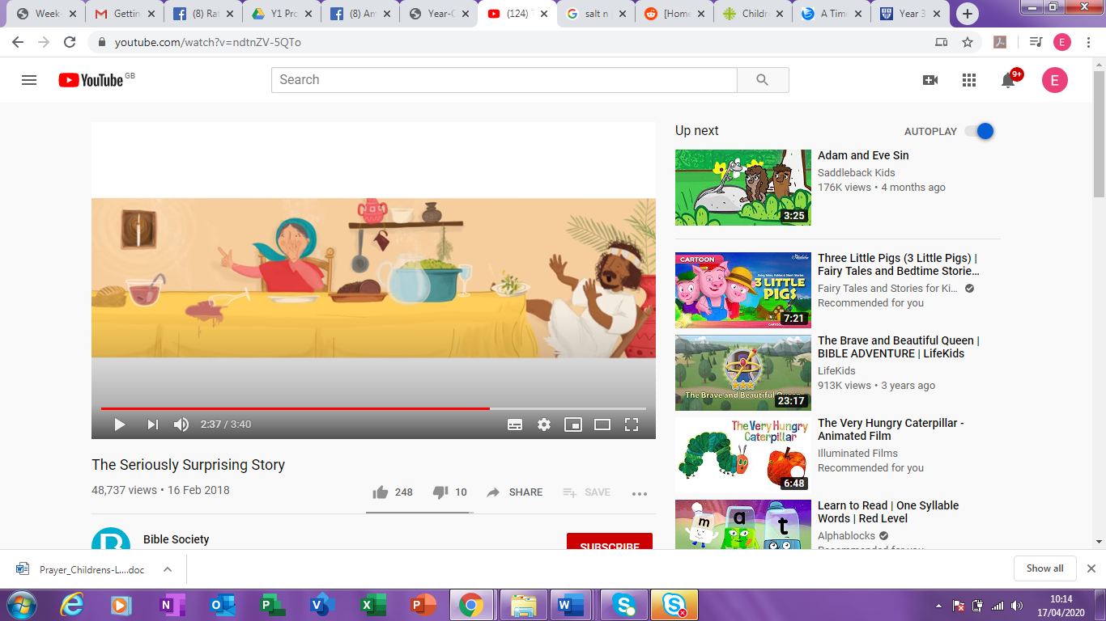[](https://www.youtube.com/watch?v=ndtnZV-5QTo)

|  |  |  |
| --- | --- | --- |
| **Maths** | **English** | **Topic** |
| **Week 1**  Complete the task that has been set for you on **Mathletics** each day. Then have a go at using LIVE Mathletics and play with your classmates (20 mins per day).  **Measuring:**   * How wide is your bedroom? Measure it using your feet, hands, socks and with a tape measure. Can you record your answers in numerals and units? * Who has the longest arms in your family? Who has the shortest arms? What is the difference between them? * Fill a cup half-full of water. Now tip some out so that it is a quarter full. Pour two quarters of water from the cup into a bowl. Does it fill it half way? Why/ why not?   **Week 2**  As above with Mathletics, plus:  **Shape:**   * Look around your house. How many things can you find with these 3D shapes: cube, cuboid, sphere, pyramid, cone. Count the faces, edges and corners. * Why wouldn’t you find an object that is a 2D shape? * Which objects can you find with faces that are: square, circular or triangular? * What is the shape of your bedroom floor?   [This Photo](http://guiastematicas.bibliotecas.uc.cl/c.php?g=697915&p=4951594) by Unknown Author is licensed under [CC BY-NC-ND](https://creativecommons.org/licenses/by-nc-nd/3.0/)  **[Image result for hit  the button](https://www.topmarks.co.uk/maths-games/hit-the-button)Want Extra?**  As above for Mathletics, then  use ‘Hit the Button’ for quickfire  practice. | **Reading**  [Image result for oxford owl](https://www.oxfordowl.co.uk/user/sign_up.html)    **Hundreds of free e-books!**  Read for at least 30 minutes per day and continue to take quizzes on Accelerated Reader.  **Daily Phonics**  **Use espresso to watch videos and play games online.**  Pick a sound from your phonics phase:   * how many things around your home can you find with this sound? * Is it at the beginning, middle or end of the word? * How many words can you think of with this sound? * Write some silly sentences using these words.   **Writing**  Write a story about your dream holiday.   * What would you do and see? * Who would be with you? | **History: Toy Detectives**    Write a letter or ask an adult to help you to email or text an older relative asking questions about their childhood. Use Twinkl if this isn’t possible.  ***Ask/Find Out:***  - which toys/ games did they have?  ***Then:***   * Use the internet with an adult to learn more about these things. * Make a poster showcasing your favourite old toys and games.   Macintosh HD:Users:JHome:Downloads:1652.png***Challenge:*** Would you rather live now or then? Explain why.  **Music**   * Listen to a family member’s favourite piece of music. * Is the music fast or slow? * Can you clap along with the beat? * Which instruments can you hear? * How does this music make you feel? |