Home Learning for Year 3 pupils from 29th June – 10th July
St. Richard’s R.C. Primary School

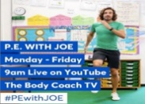
CLICK THE IMAGES TO VISIT THE LINKED WEBSITES
This Photo by Unknown Author is licensed under CC BY-NC-ND
Start your day with some exercise – tune in to PE with JOE WICKS!
Join the daily 20 minute session at 9.00am

Monday 29th June is the feast day for Saint Peter and Saint Paul. As early as the 3rd or 4th century, the lives of Saint Peter and Saint Paul have been celebrated on the same day; a holy day of obligation in most Catholic traditions.

Watch the video clips to learn about the lives of Saint Peter and Saint Paul. Peter was a fisherman when Jesus called him, and both Peter and Paul became ‘fishers of men’. Draw 2 fish outlines on paper. Write in one what you have learned about Saint Peter’s life, and write about Saint Paul’s life in the other.

Religion

Maths | English | Topic History: Stone Age
Complete learning tasks and use live play on Mathletics to keep your skills sharp!  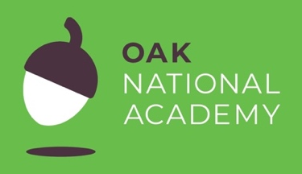  Use the Oak National Academy website to complete one maths lesson per day. This time, focus on ‘Angles and Shape’.  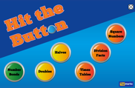  You can also use the TopMarks website to help with your mental methods and tables work. Use ‘Hit the Button’ for quickfire  practice.  Want Extra?  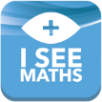 | Hundreds of free e-books!  Read for at least 30 mins per day and continue to take quizzes!  Use the BBC home learning website to complete one English lesson per day.  If you have a Nessy login, make sure that you complete the tasks on your level.  Listen to the story ‘How to Wash A Woolly Mammoth’ by Michelle Robinson & Kate Hindley. Write your own instructions about how you would wash a woolly mammoth! | Revisit your learning about the Stone Age with this PowerPoint from Twinkl.  Activities you could do at home:  - Create your own Stone Age cave painting  - Use natural resources to make your own Stone Age tools or jewellery  - Follow this recipe to make Stone Age stewed fruit  - Create a timeline showing the changes that happened during the Stone Age  - Research about the famous prehistoric village Skara Brae and write a non-chronological report on what you can find out.  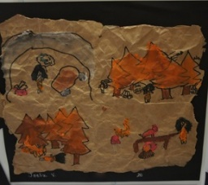

Please remember that Accelerated Reader logins will not work if you try to access the site via a Google search. Please make sure you use the school’s unique link
Parents, please register for the websites listed in order for your child to access them. They are free but will need some details such as an email address from you.

