PE News November 2021

After-school Clubs

The new half-term has seen the re-start of the after-school clubs with new groups of pupils. We have now been able to accommodate all term pupils who asked for a place at the start of the year. Below are some photos showing some of the action from the clubs before half-term.

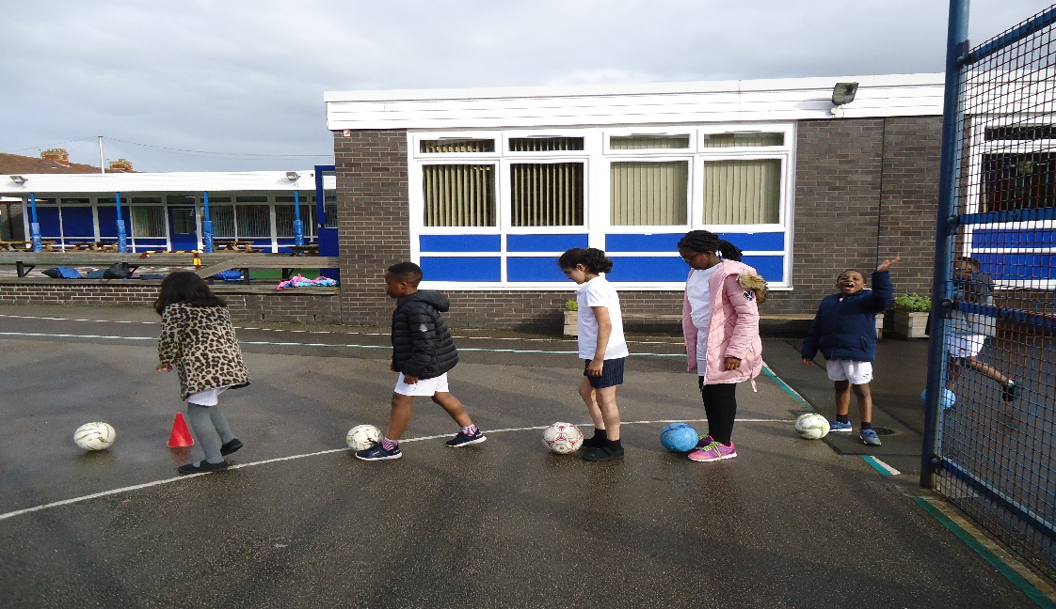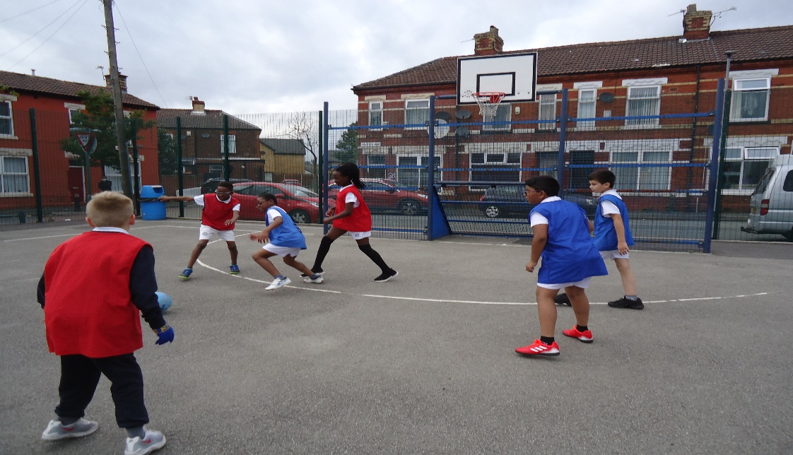
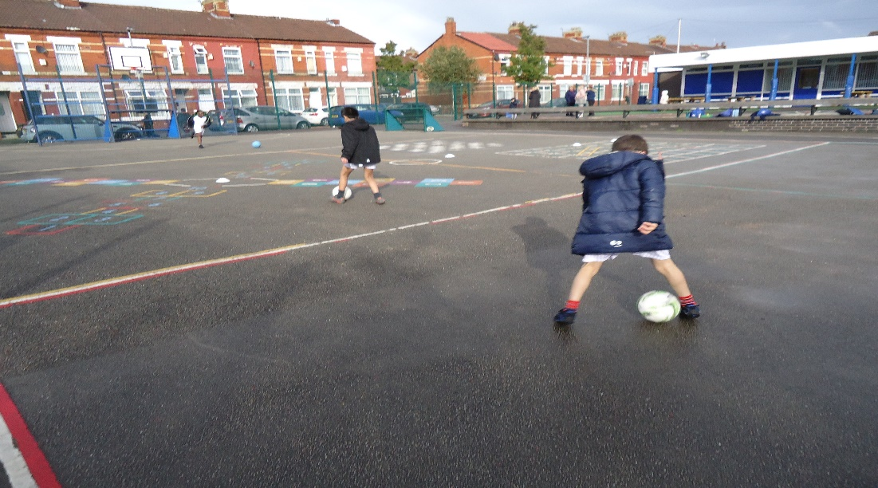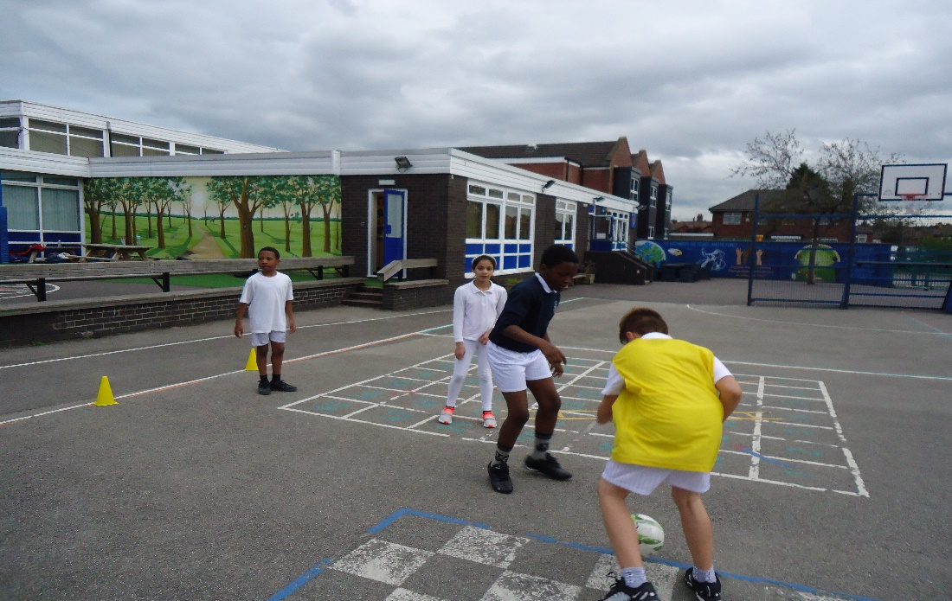

The full programme of after-school clubs is as follows:

Monday – Year 4 football club
Tuesday – Year 3 multi-skills club
Wednesday – Year 6 girls’ football club
Thursday – Year 5 football club

All clubs finish at 4.15 pm.

Girls’ Football Tournament

Unfortunately, the Year 6 girls’ football tournament for October was cancelled due to bad weather, just as the September tournament was.
Let’s hope for better weather on November 16th.

Upcoming Tournaments

The new year will be a busy time for our Year 6 pupils, with tournaments in basketball, hockey and cricket.

