PE News February 2022

After-school Clubs

There is a different club running each night after school from Monday to Thursday. There has been a great demand for the 16 places in each club. Any child not obtaining a place this half-term will be given a place next half-term.
We hope to run clubs for Key Stage 1 pupils later in the year.

The full programme is as follows:

Monday – Year 4 football club
Tuesday – Year 3 multi-skills club
Wednesday – Year 6 boys’ multi-skills club
Thursday – Year 5 football club

Tournament News

Basketball Tournament
BIG GAME!
Team - Adam, Ivana, Gabby, Barack, Aaron, Sienna D and Tresor
Some of St Richards best basketball players, teamed up to go and play St Francis A, St Francis B and Armitage.
This competition was held at St Peters.
Adam scored an amazing 11 points! Gabby scored an incredible 4 points! Barack scored an impressive 3 points!
The rest did not score any but still played a big part: teamwork, determination, respect and honesty.
We won all of our games except one against Armitage!
Overall, we came second, which is amazing! Even though we did not win, we all worked together and had a fantastic time!
Written by GABRIELLA!
Winners
On Tuesday, St Richard’s became East Manchester Basketball Champions in an exciting tournament at St Peter’s basketball centre.
In the first game we won 4-2 against
St Francis A. In the second game we drew 4-4 against Armitage and in the third game we beat St Francis B 4-2. All 3 games were played in a friendly and sporting way.
The team have now qualified for the Manchester Basketball Finals, which take place at St Peter’s in two weeks time.
Our heroes are below, looking very pleased with themselves.

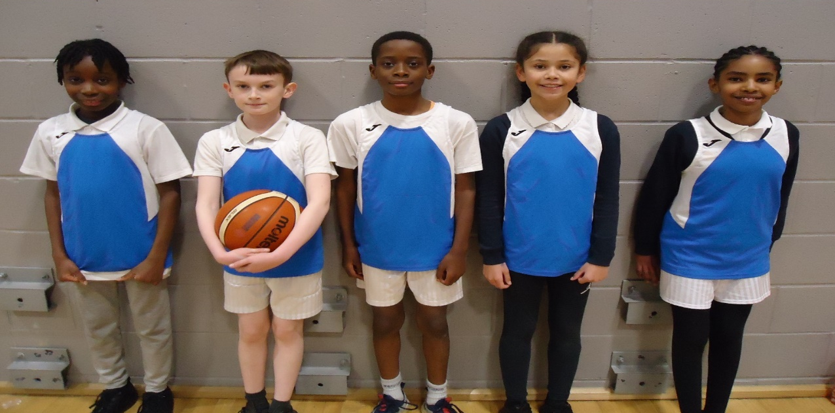
Hockey
On Thursday 3rd February, the first hockey tournament was held at Cedar Mount High School. Our hockey team played 4 matches. They won the first against Armitage, before losing narrowly to St Francis, Haveley Hey and All Saints.
The team represented their school with great pride and showed fairness, respect and good will to the other teams.
