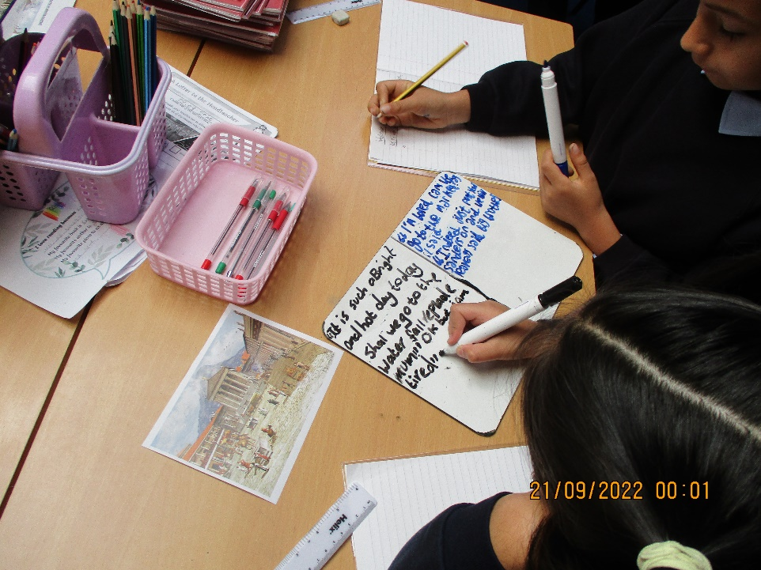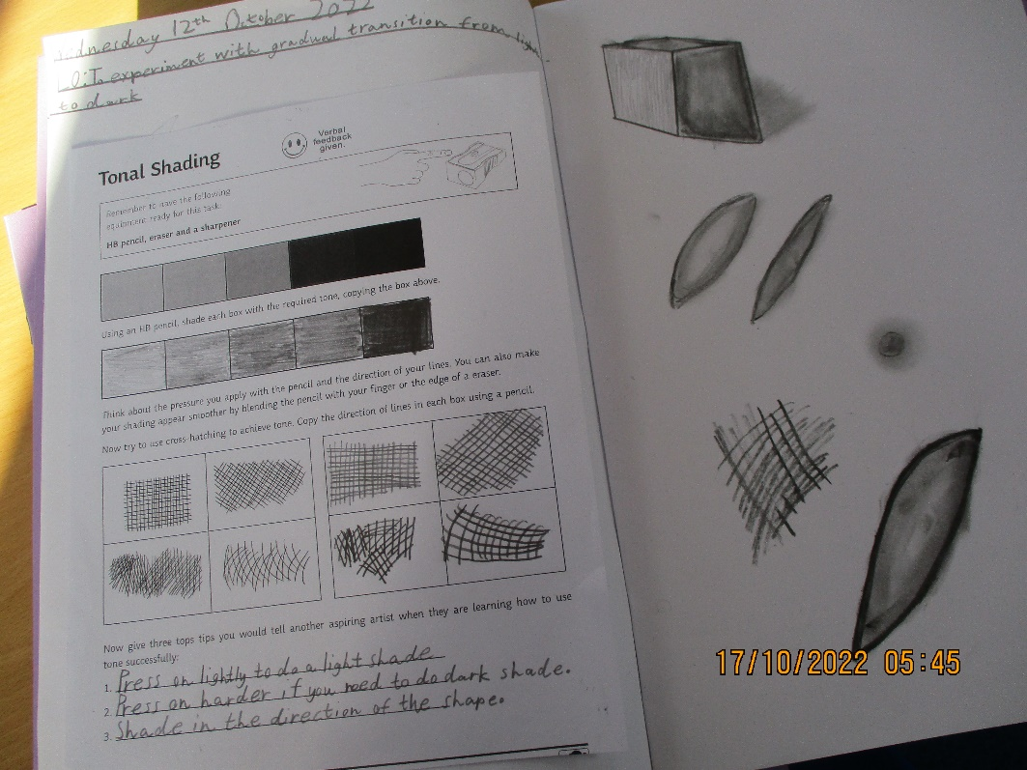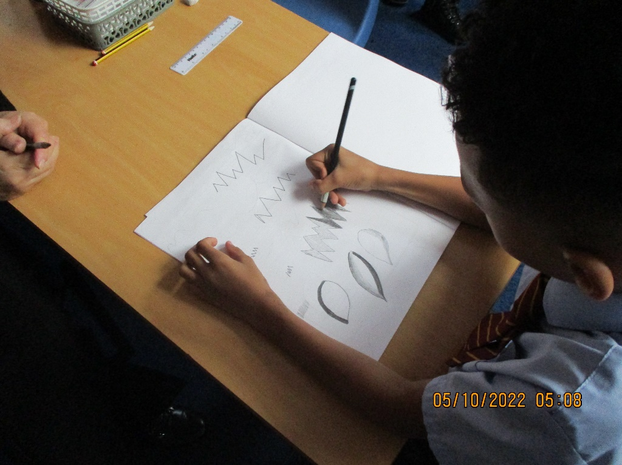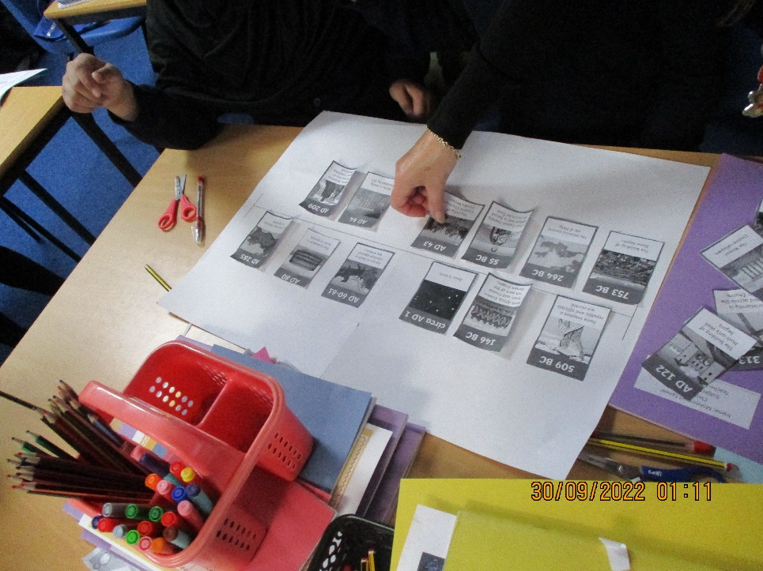

In our first piece of writing we used a dialogue opener. We worked together to make sure our introduction was effective.

During our Art lessons we have been working on blending from light to dark using sketching pencils.

In year 4 our first History Topic is the Romans. We worked in groups to make a timeline of key events.