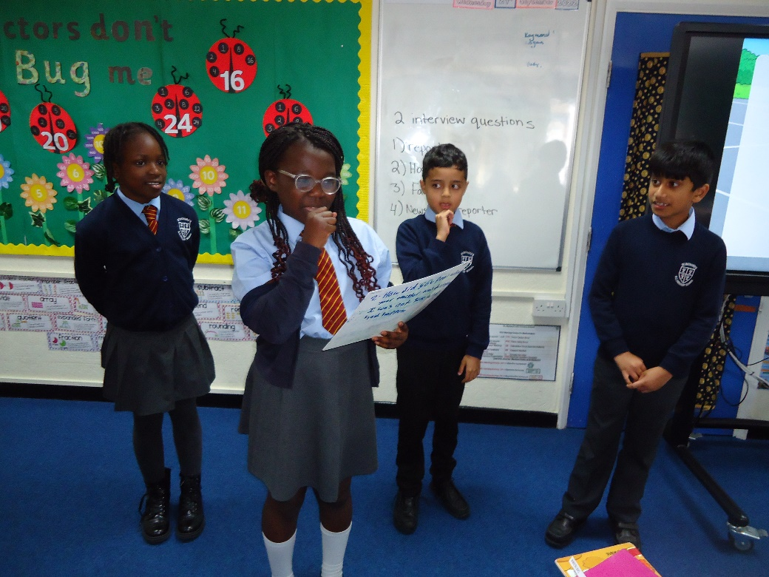
Class 9 Autumn 1
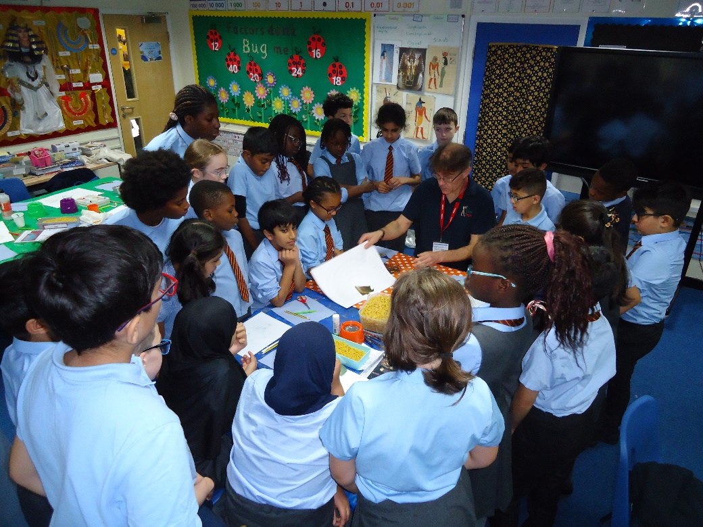
In Literacy, Class 9 wrote a newspaper article based on the events in chapter 2 of Ted Hughes’ The Iron Man. To help consolidate their knowledge of direct and reported speech, they interviewed witnesses of the events that occurred in the book to get quotes to include in the newspaper articles.
Mr. Tony North visited Class 9 to deliver a workshop on Ancient Egyptian fashion and culture to link with our History topic on the Ancient Egyptians. There was an opportunity to smell some perfumes and some lucky children even got to dress as Egyptians! Everyone got to make some Egyptian jewellery including necklaces, bracelets, mirrors and collars.
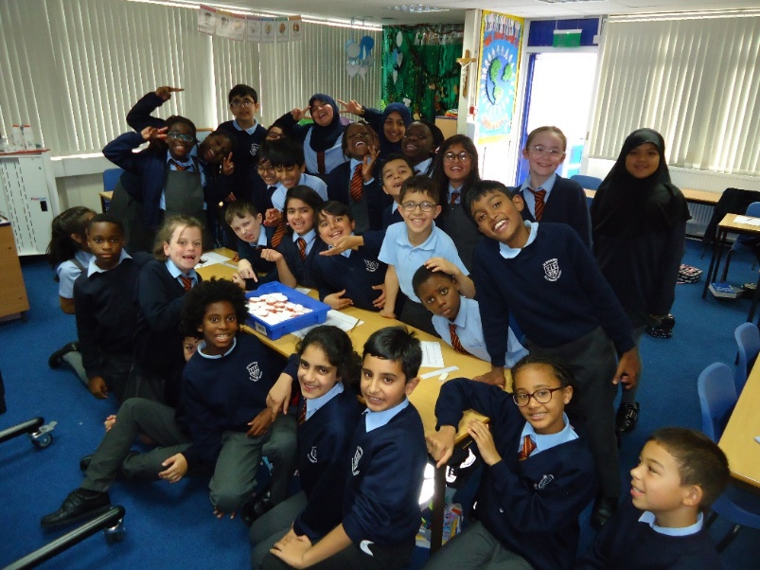
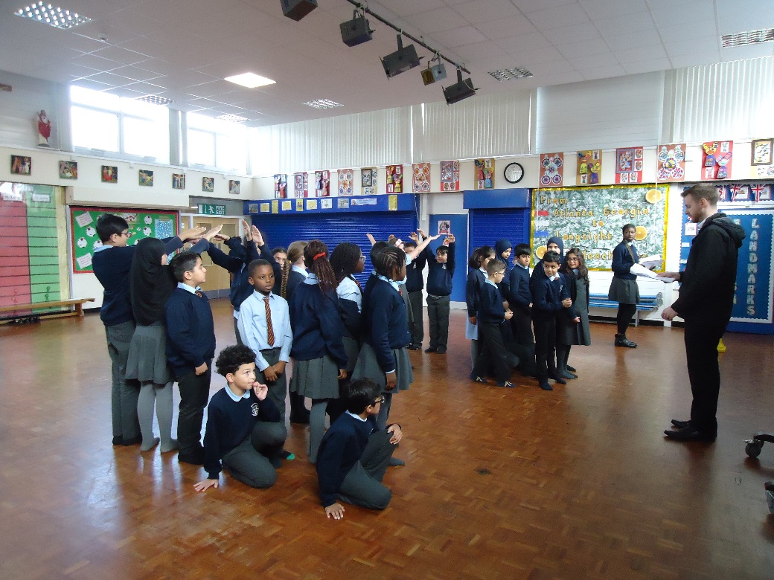
Class 9 is hard at work preparing their production of Shakespeare’s Romeo and Juliet. Weekly practices have been occurring in the school hall and they have also participated in workshops run by the Coram Shakespeare Schools Foundation. The final performance will be on 2nd November at the Contact Theatre in Manchester.

To help build upon previous knowledge of Egyptian mummification, Class 9 became Ancient Egyptian embalmers. Don’t worry, we mummified tomatoes instead of real bodies! In 2 weeks, we will check on the tomatoes to see what has happened.

