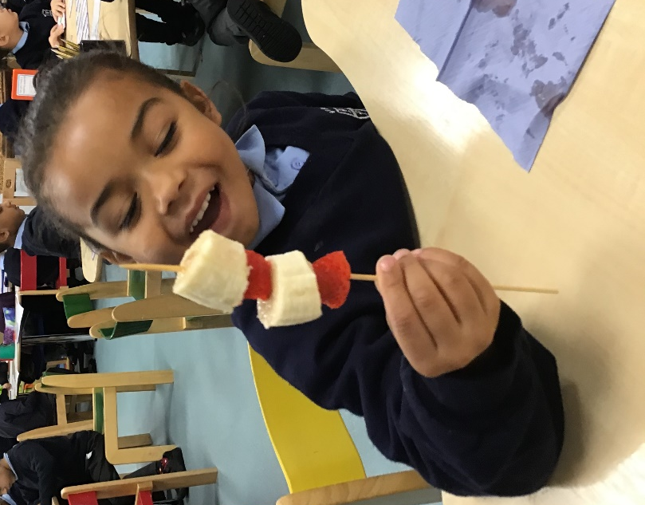
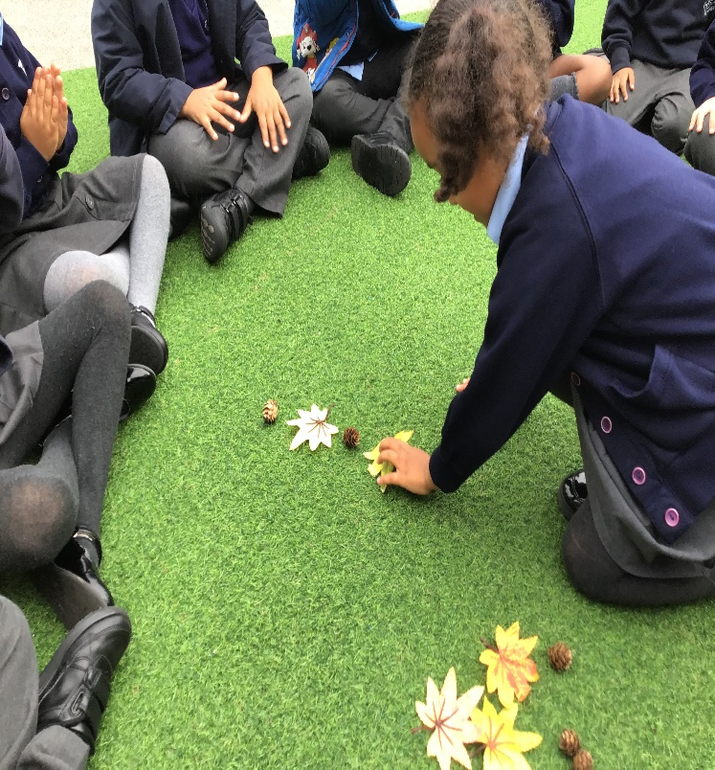
In math we have been exploring repeating patterns. We used lots of different objets to make patterns but our favourite was the fruit kebab patterns.
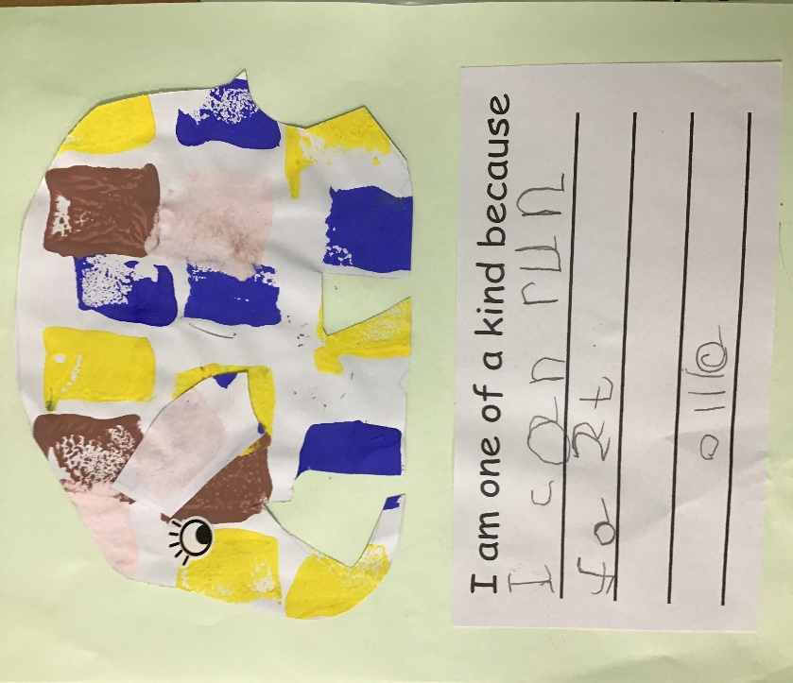
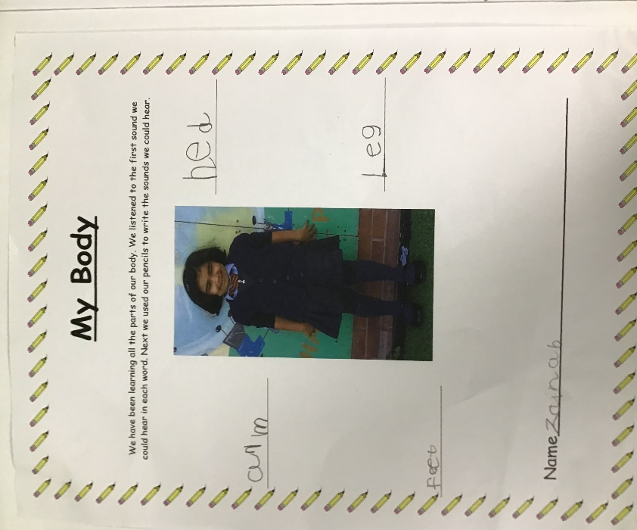

In Literacy we have read lots of stories this term our favourites were Funny Bones and Elmer. We labelled the parts of our body and talked all about how we are all one of a kind just like Elmer.

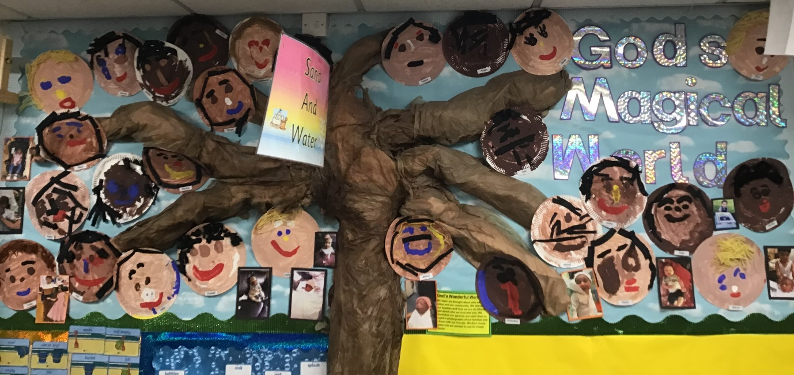
We have learning all about our families and how they all different and special. We created our very own family tree. We brought pictures in from home and shared them with our friends.

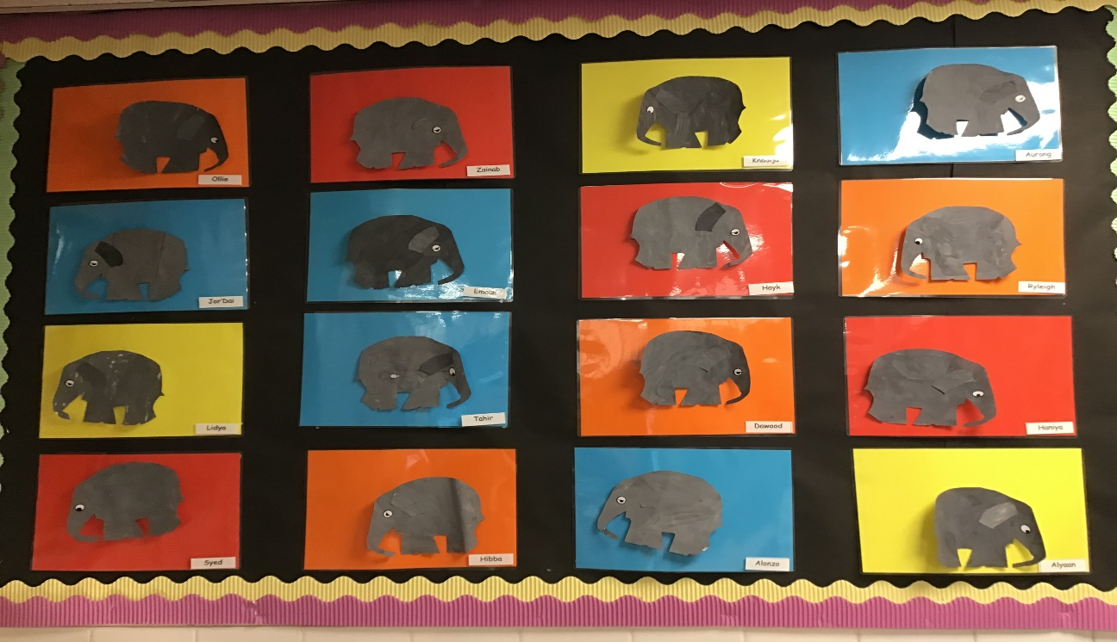

We have been exploring a range of different skills in our Elmer Art Project. We have made patterns, collaged and experimented with colour mixing.

