**Class 11 Autumn 1 Photos**

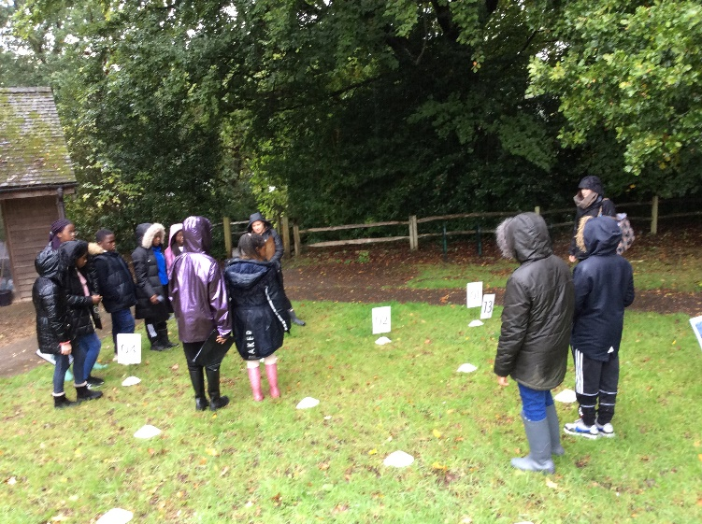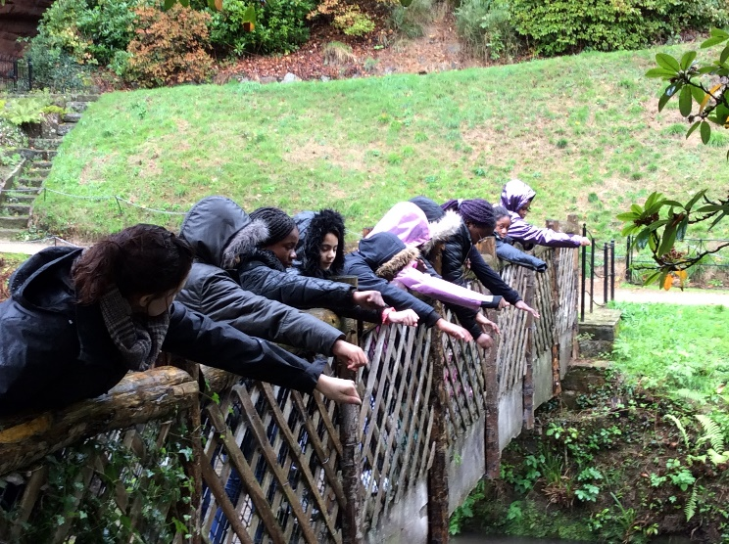

During our Geography trip, we also practised using both four- and six-figure grid references using a life-sized grid on the floor.

Here we are investigating the speed of the water on a meander, when we visited Quarry Bank for two outdoor workshops: Map Challenges and Exploring the River Bollin.

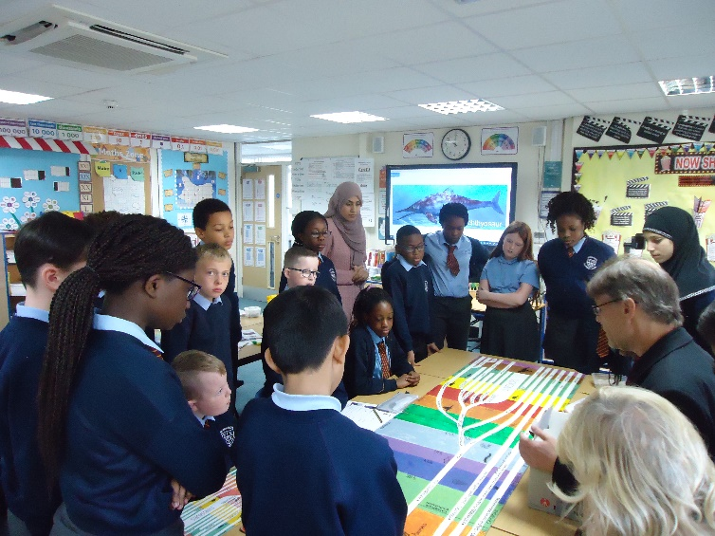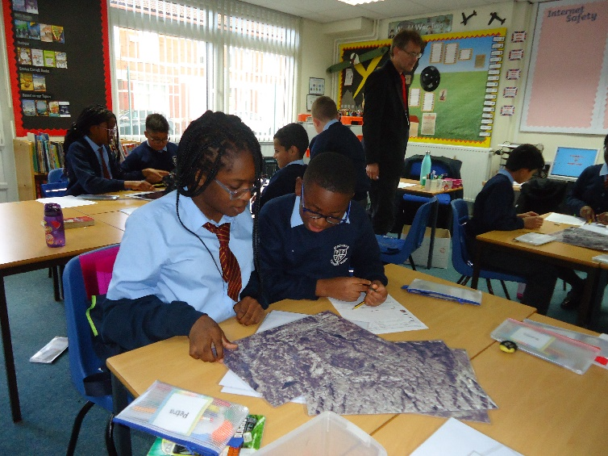

Mr North visited us to teach us about Evolution and through studying the tree of life, we established that all living things are related.

We completed a simulation to investigate what happened to the peppered moth in the 1800s and learnt that it was essential for the peppered moth to change to suit its environment in order for it to survive.