Class 5 –Autumn 1
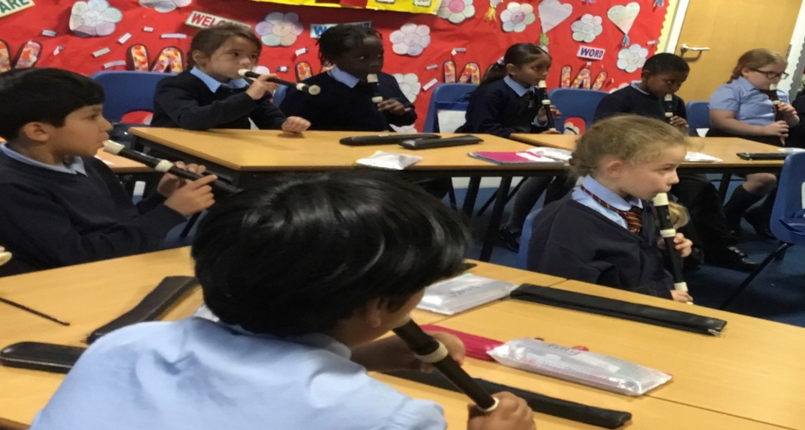
In class 5 this half term, we have been enjoying working on pulse, pitch and rhythm with Mrs Buckler. We love our music lessons and have even been lucky enough to get out some musical instruments too!
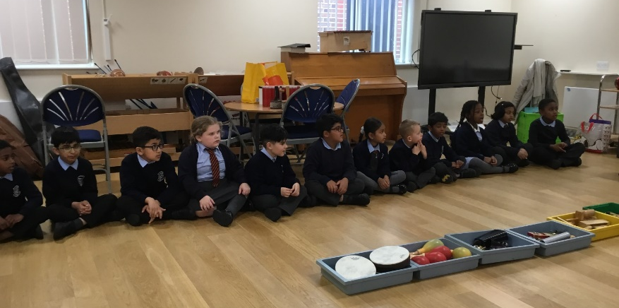

In our science lessons this half term we have been learning about skeletons and the human body. We investigated whether or not taller people have longer bones by measuring different bones and comparing them to height. Our predictions were right, taller people do have longer bones!!

