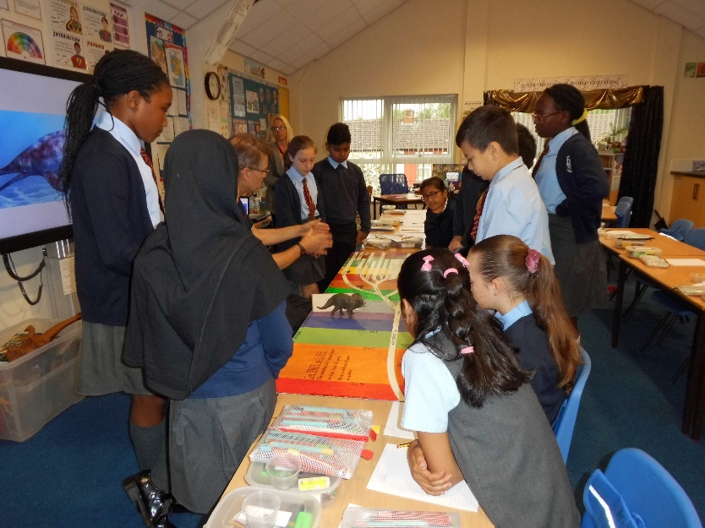

**Class 12**

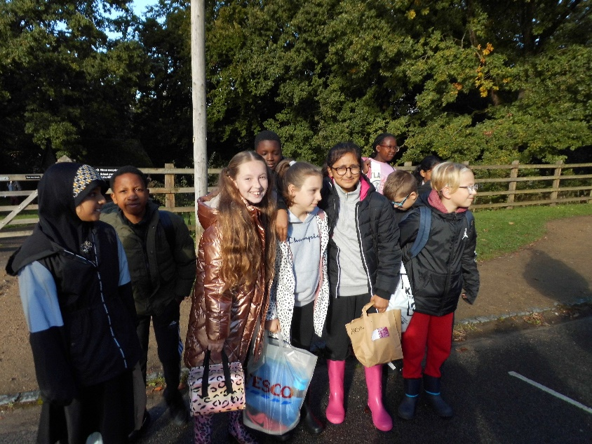

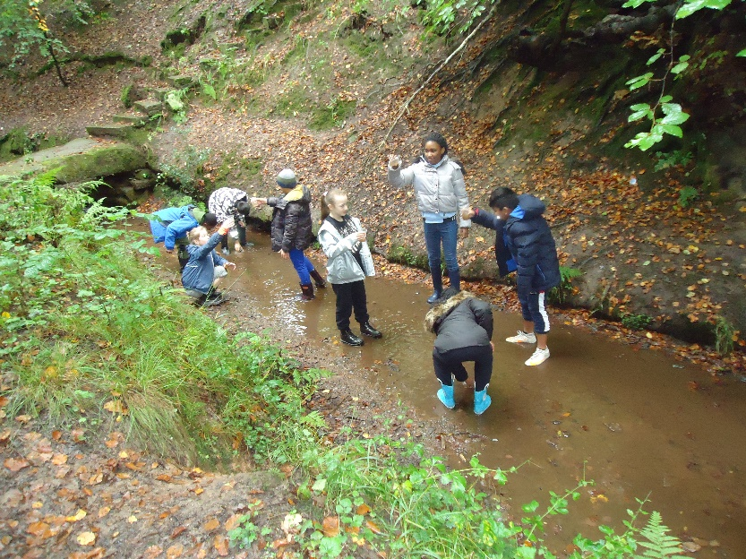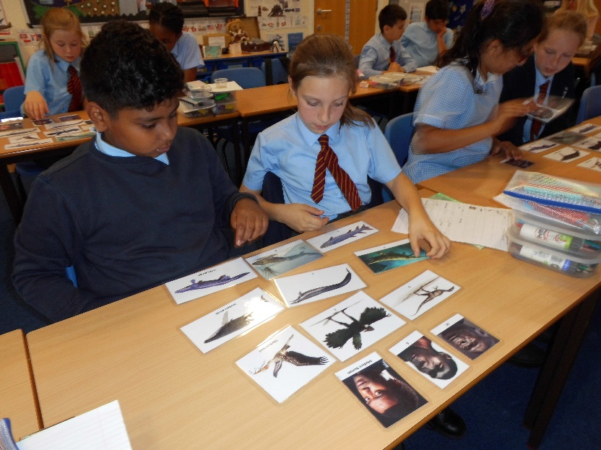

We visited Quarry Bank & the River Bollin as part of out Geography topic this half term. Here some of us are raring to get started! While we were there we did map challenges and also practised using both four-figure and six-figure grid references using a life-sized grid on the ground.

Some of the class (the ones with wellies!) then moved into the River Bollin to take water samples to find out how clean the water is. We also investigated the speed of the water on a meander and went pond dipping with our nets. Then we were challenged to identify the pond creatures we had collected using magnifiers and charts.

We then identified how living things have evolved and adapted to suit their environment over many years. We also completed a simulation to investigate what happened to the peppered moth in 1800s Manchester with the arrival of factories. We learnt that it had to adapt to suit its new environment. We also made our own fantastic creatures with specific adaptive traits to help them survive in their habitats.

Mr North visited us to teach us about Evolution and Adaptation. We started the day studying ‘The Tree of Life’, finding out how all living things are related to each other and how they have evolved over millions of years.