Autumn Term 1 Class 8
History- The Romans
In order to understand the spread of the Roman Empire, we went through a presentation and discussed significant dates in that period of time. We worked in groups to create a timeline in chronological order.
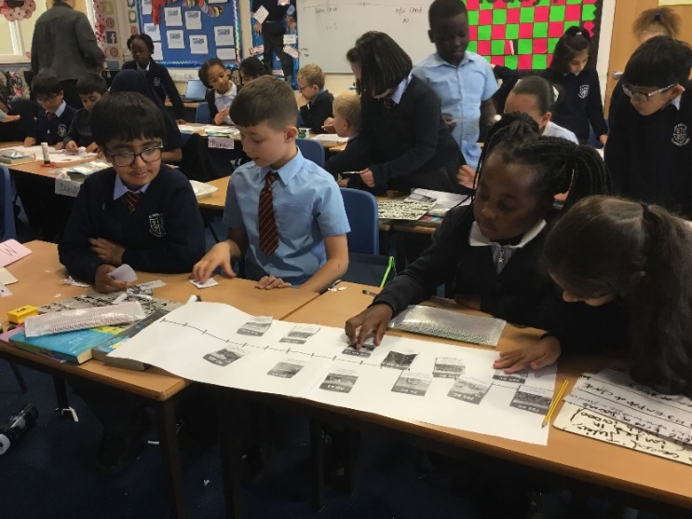
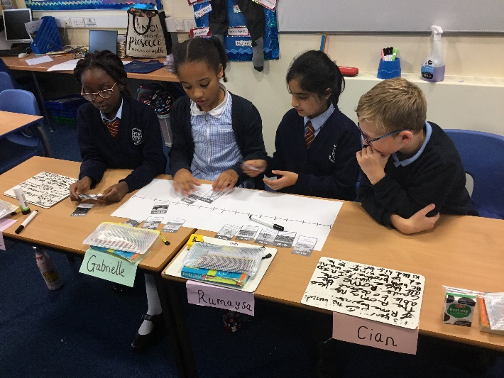

Mathematics- Place Value
In Class 8 we have been looking at rounding numbers to the nearest 10, 100 and 1000. We went have done some outside learning by creating number lines using our chalk and our bodies.

