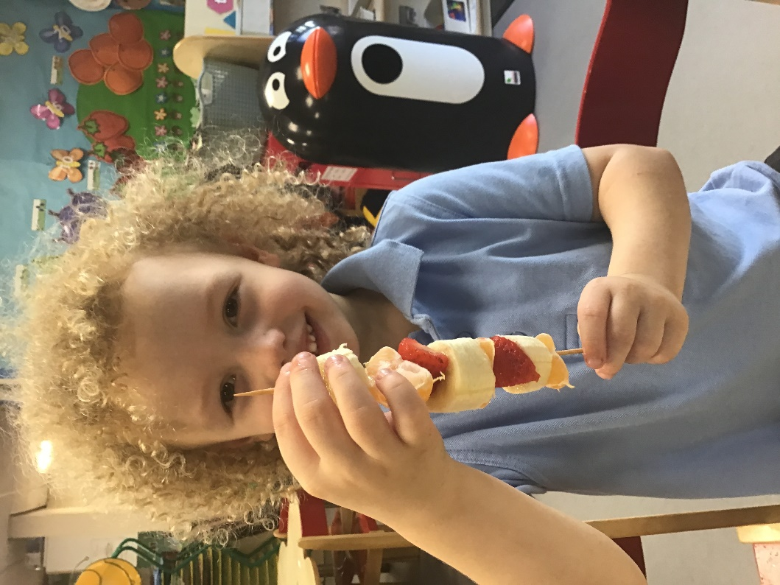

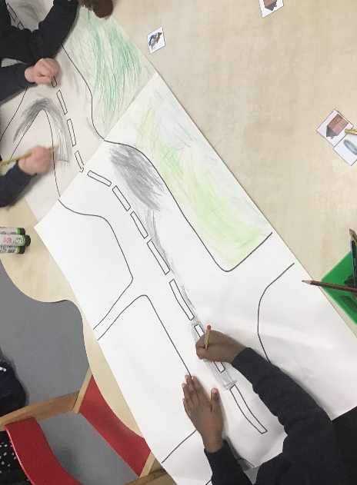
We have been learning about patterns in maths and even made our own fruit kebabs. We had so much fun choosing different fruits and they were delicious!
We have been learning all about our local community in topic! We used Google Maps to find our school, our church, parks, roads and shops in the area. We then used what we had learnt to build our own class map!

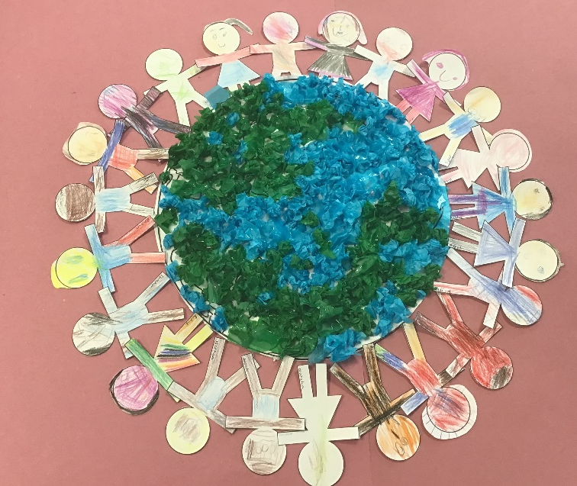
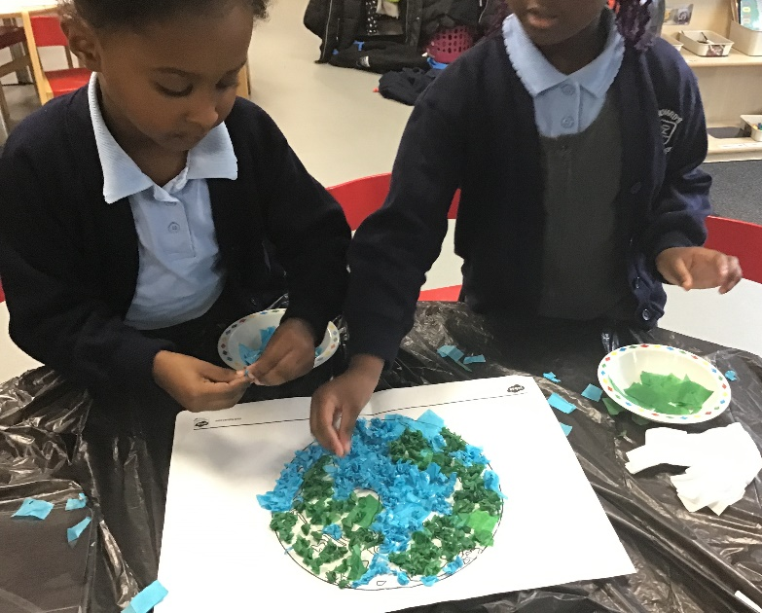
In R.E., we have been learning about how we are all unique. We found out what our family names were and talked about how family is important. We explored how we are all a part of God’s family and how we are all important to God.

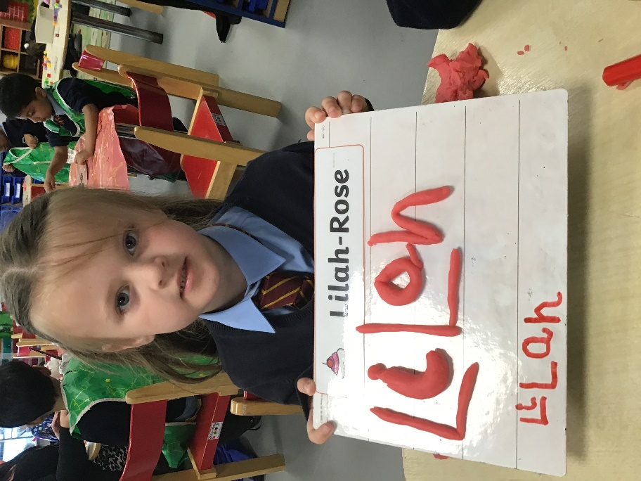

This term, we have been working hard to practise writing our names. We write our names everyday when we come into school. In literacy, we even practised writing our names with playdough, pen, crayons, paint and pencils!

