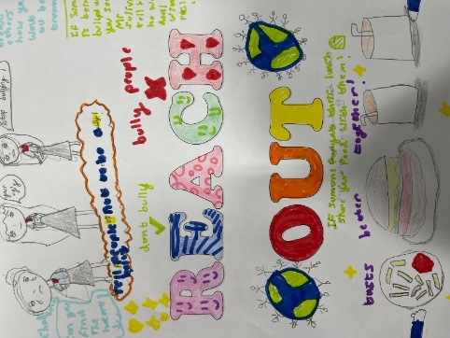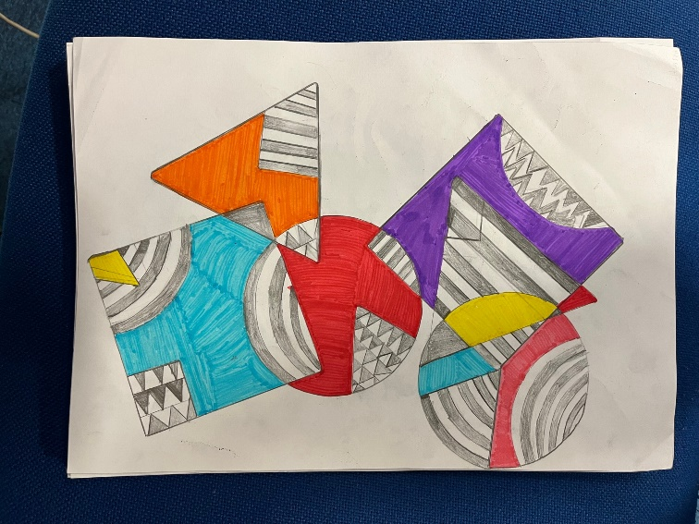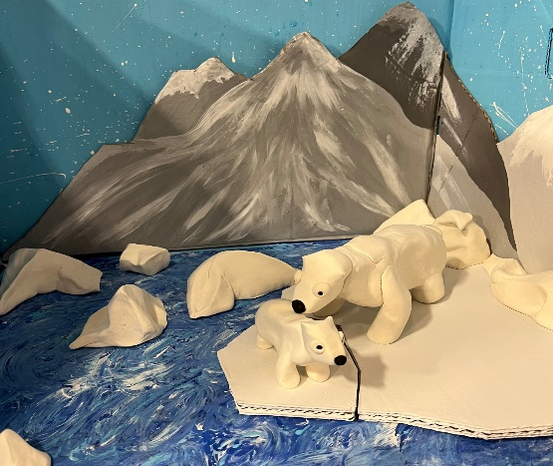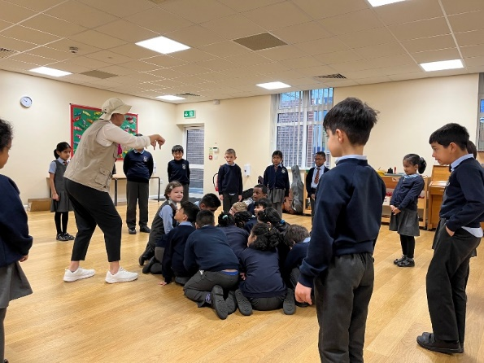

We combined our Computing skills with our PSHE topic to produce an animation all about the effects of climate change.

We made posters around the theme of ‘Reach Out’ for anti-bullying week, including ways we could support each other and keep each other safe.

We have been combining skills in art to produce our own geometric designs, with a mix of colour and patterned fills.

As part of an Extreme Earth drama workshop, the pupils pretended to be a volcano – erupting and cooling and growing in size.

**Class 6**