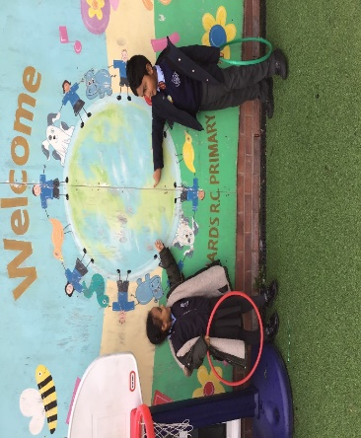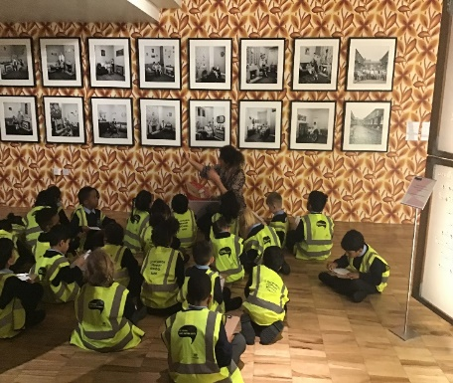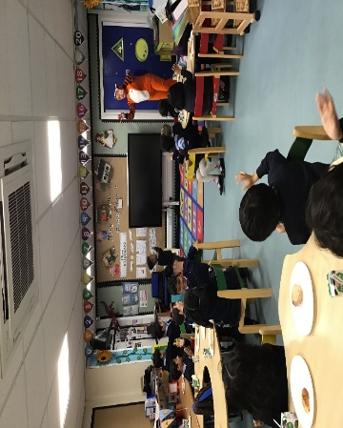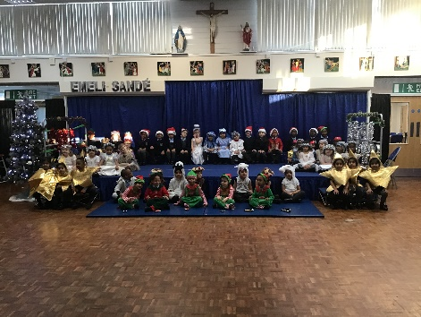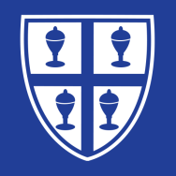

In topic this half term we visited The Whitworth Art Gallery

In maths we have been on a shape hunt around our school

In Literacy this term we had a tiger tea party!

In RE this term we have been learning the Nativity story

**R2**