

During French, we also learned about the mathematician Professor Nira Chamberlain OBE as it was Black History Month!

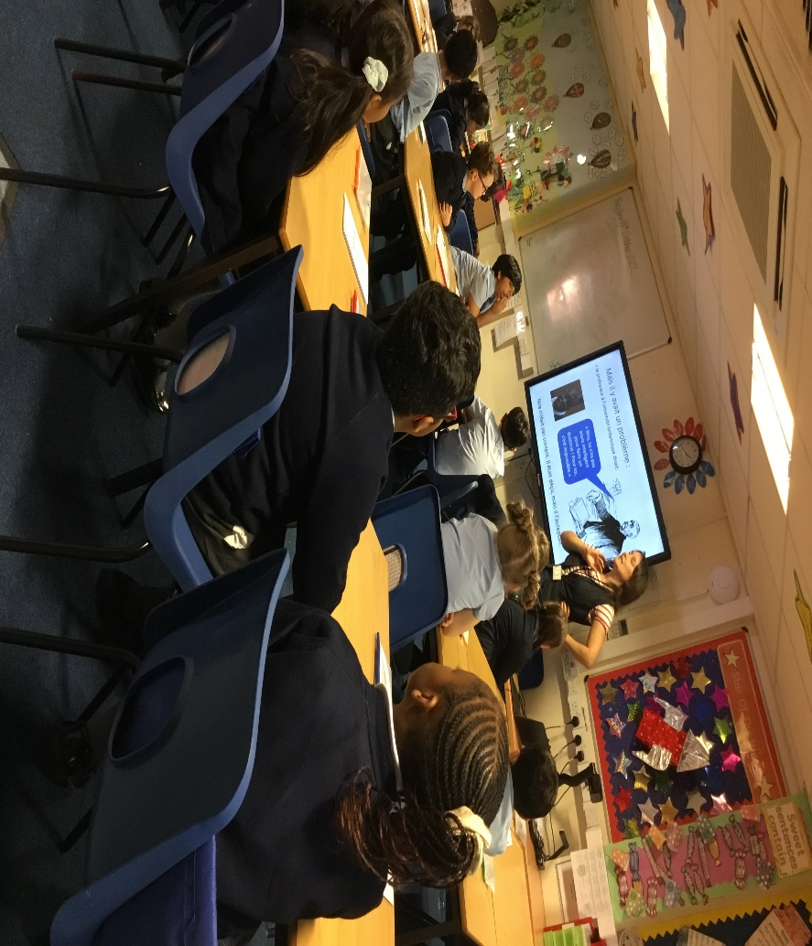

We acted out how a tsunami is created, what we might do if there was an earthquake and what happens when there is a tornado.

In Geography, our topic is extreme earth and we had a workshop which helped us to remember all about the different types of extreme weather.

We love to sing in French, here we are singing a song –can you guess which animal it’s about??

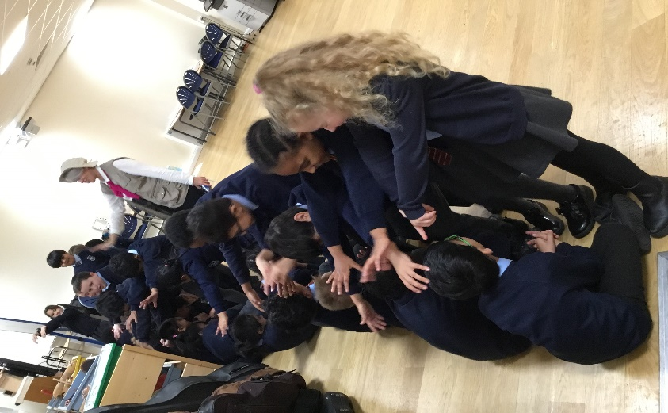

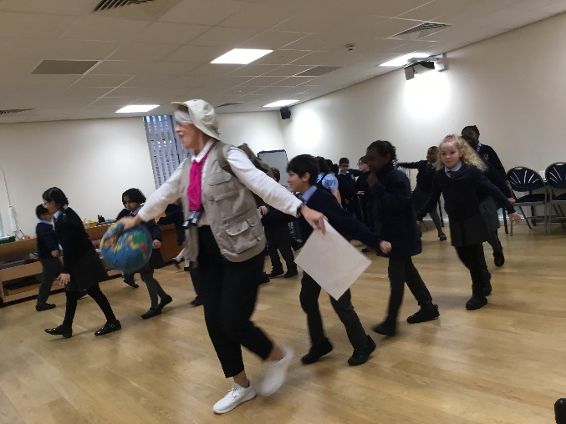

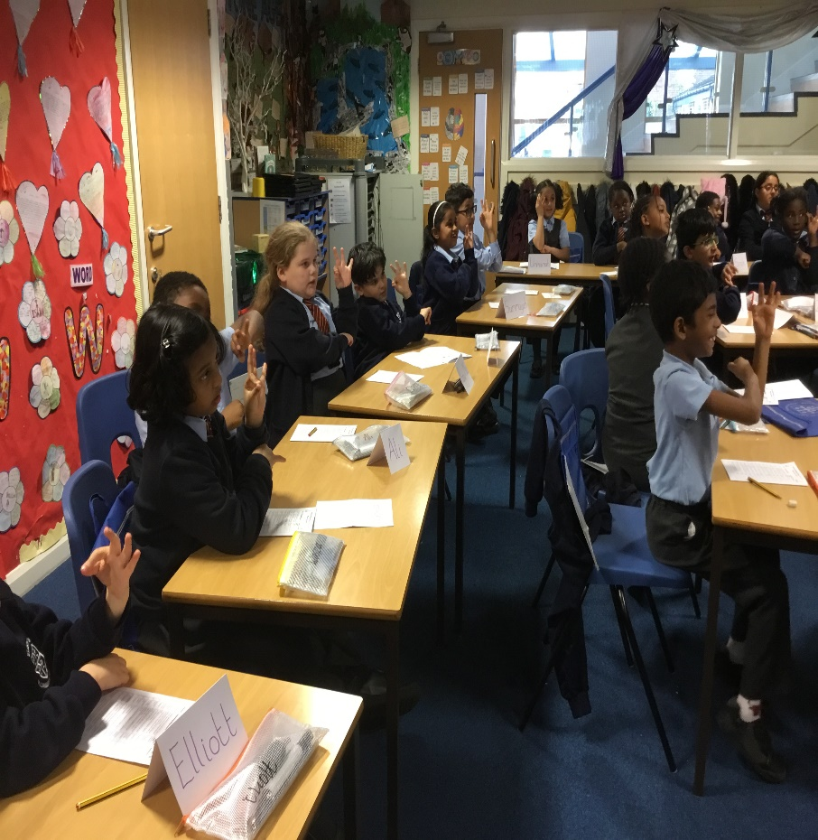

**Class 5**