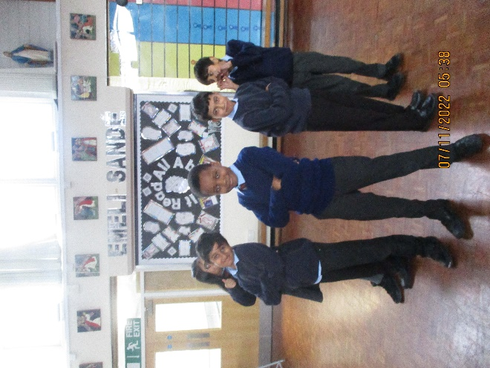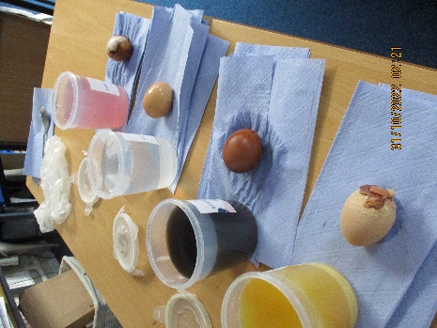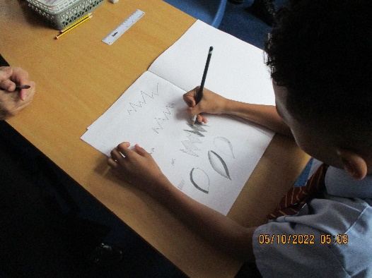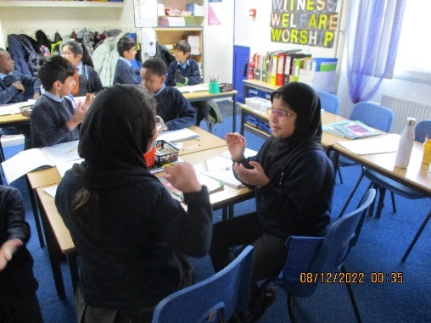

To end our History topic on the Romans we learnt a Roman song and worked in groups to re-enact Roman army formations.

We conducted a science experiment to investigate which liquid would damage the enamel on our teeth the most. We used hard boiled eggs as the hard shell is similar to the enamel on our teeth.

During our art topic we have been learning how to blend between light and darker shades using sketching pencils.

In class 7 we have been learning our times tables. We have been playing games in partners to help us remember them.

**Class 7**