

Our Science topic was about Animals including humans and we did an experiment using eggs in different liquids to observe tooth decay as the shell on an egg is similar to enamel on out teeth.

Throughout our Relationship Studies and Religion we have been thinking about the qualities that make a good friend and a good Christian.

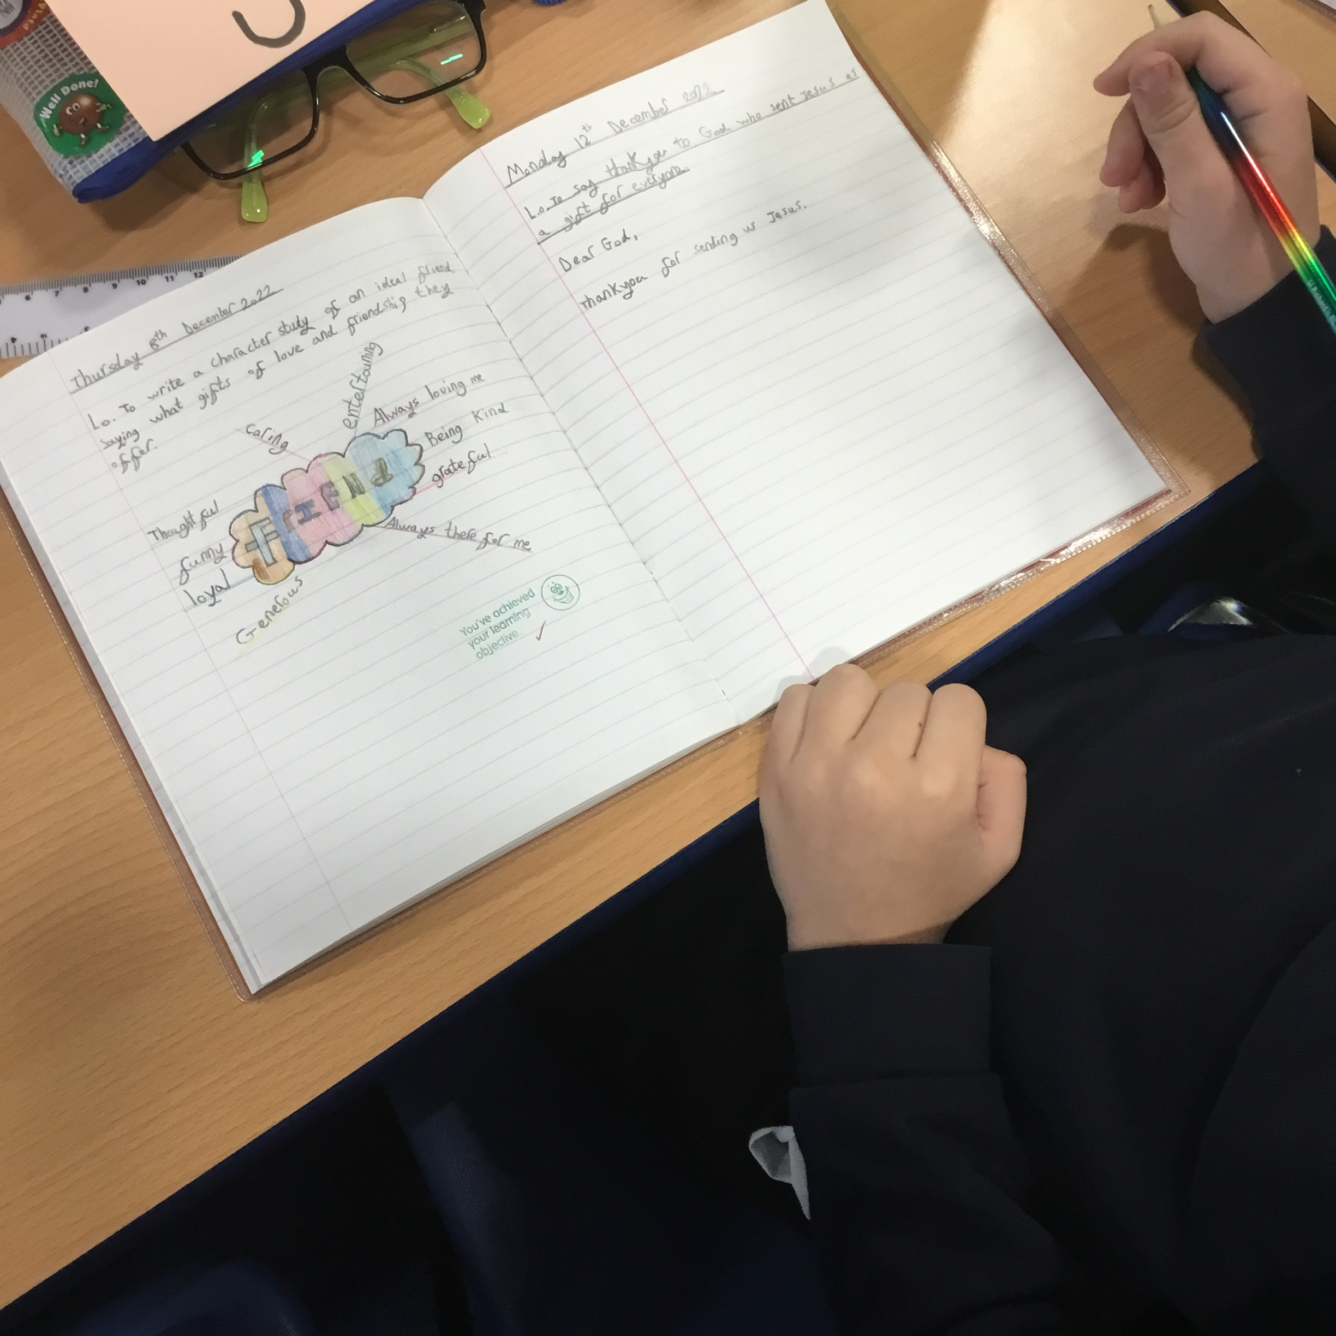

The Romans topic saw us look at different battle techniques used by soldiers and we went outside for a drama lesson to re-enact these army poses.

In Religion, this month we have been talking about the importance of Advent in the Christian calendar and have produced kindness advent calendars.

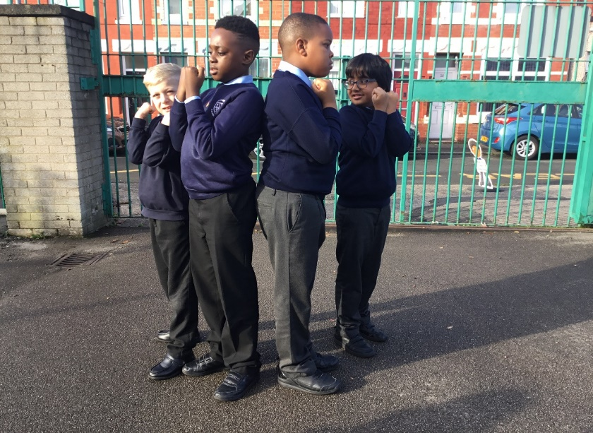

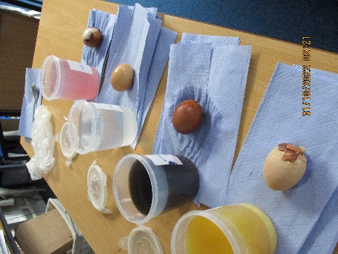

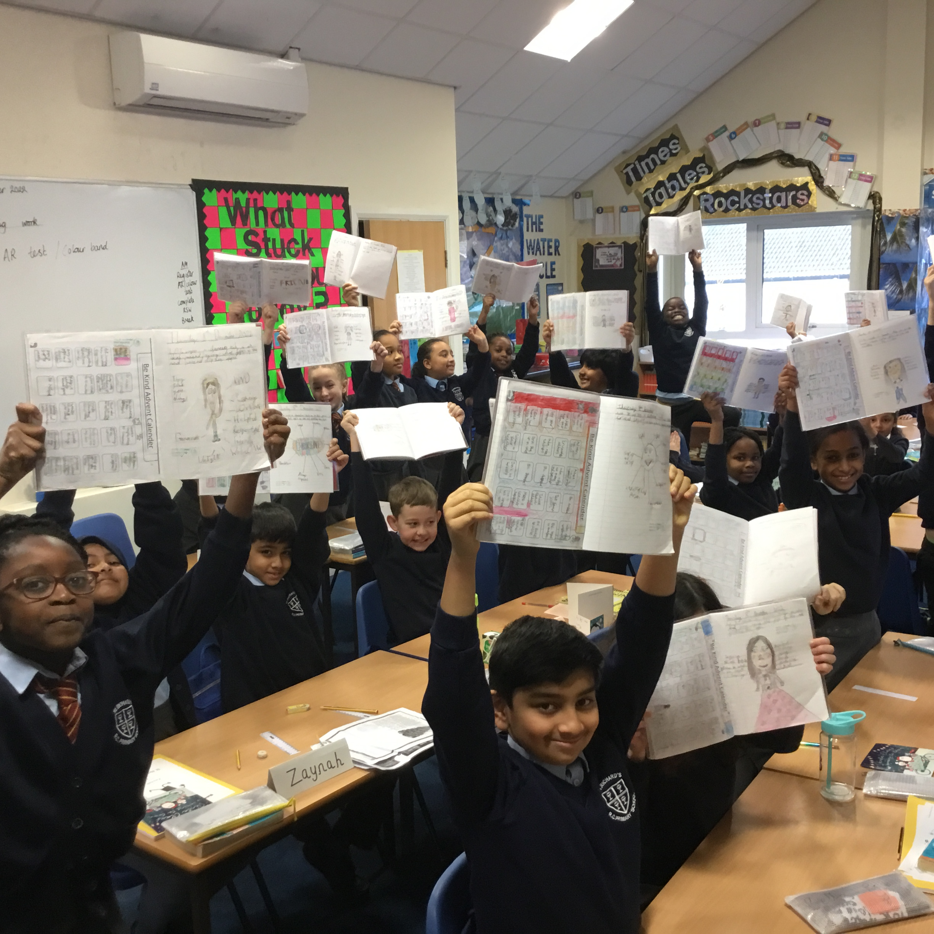

**Class 8**