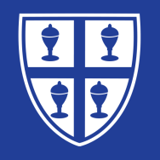

In history lessons, we analysed many **historical sources** to help us determine whether the Battle of Dunkirk was a **‘miracle’** or **‘disaster’** for the British.

In our Design and Technology lessons, we designed and made a **motorised vehicle** which included a circuit and pulley system.

During our religion lessons, we learned about Saint Brigid and we each made a lovely **Saint Brigid’s cross.**

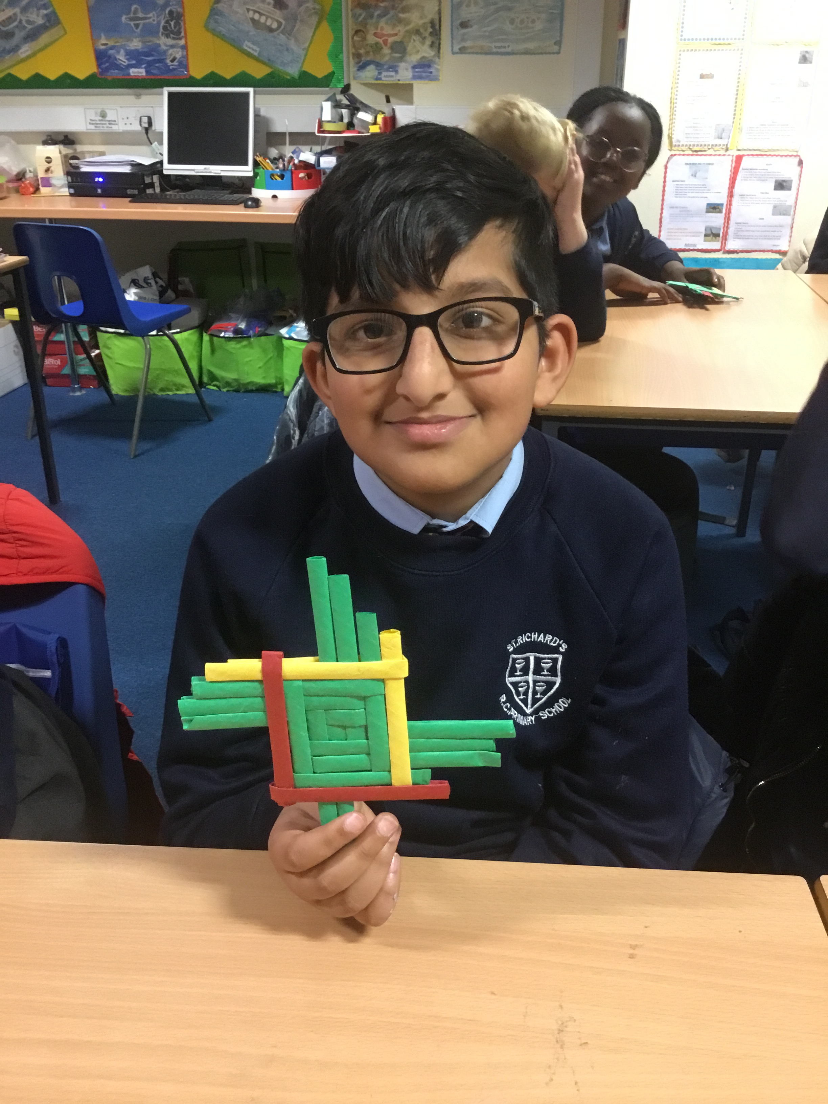

In our art lessons, we learned all about **‘Tie Dye’** techniques and effects. We created these fantastic t-shirts!

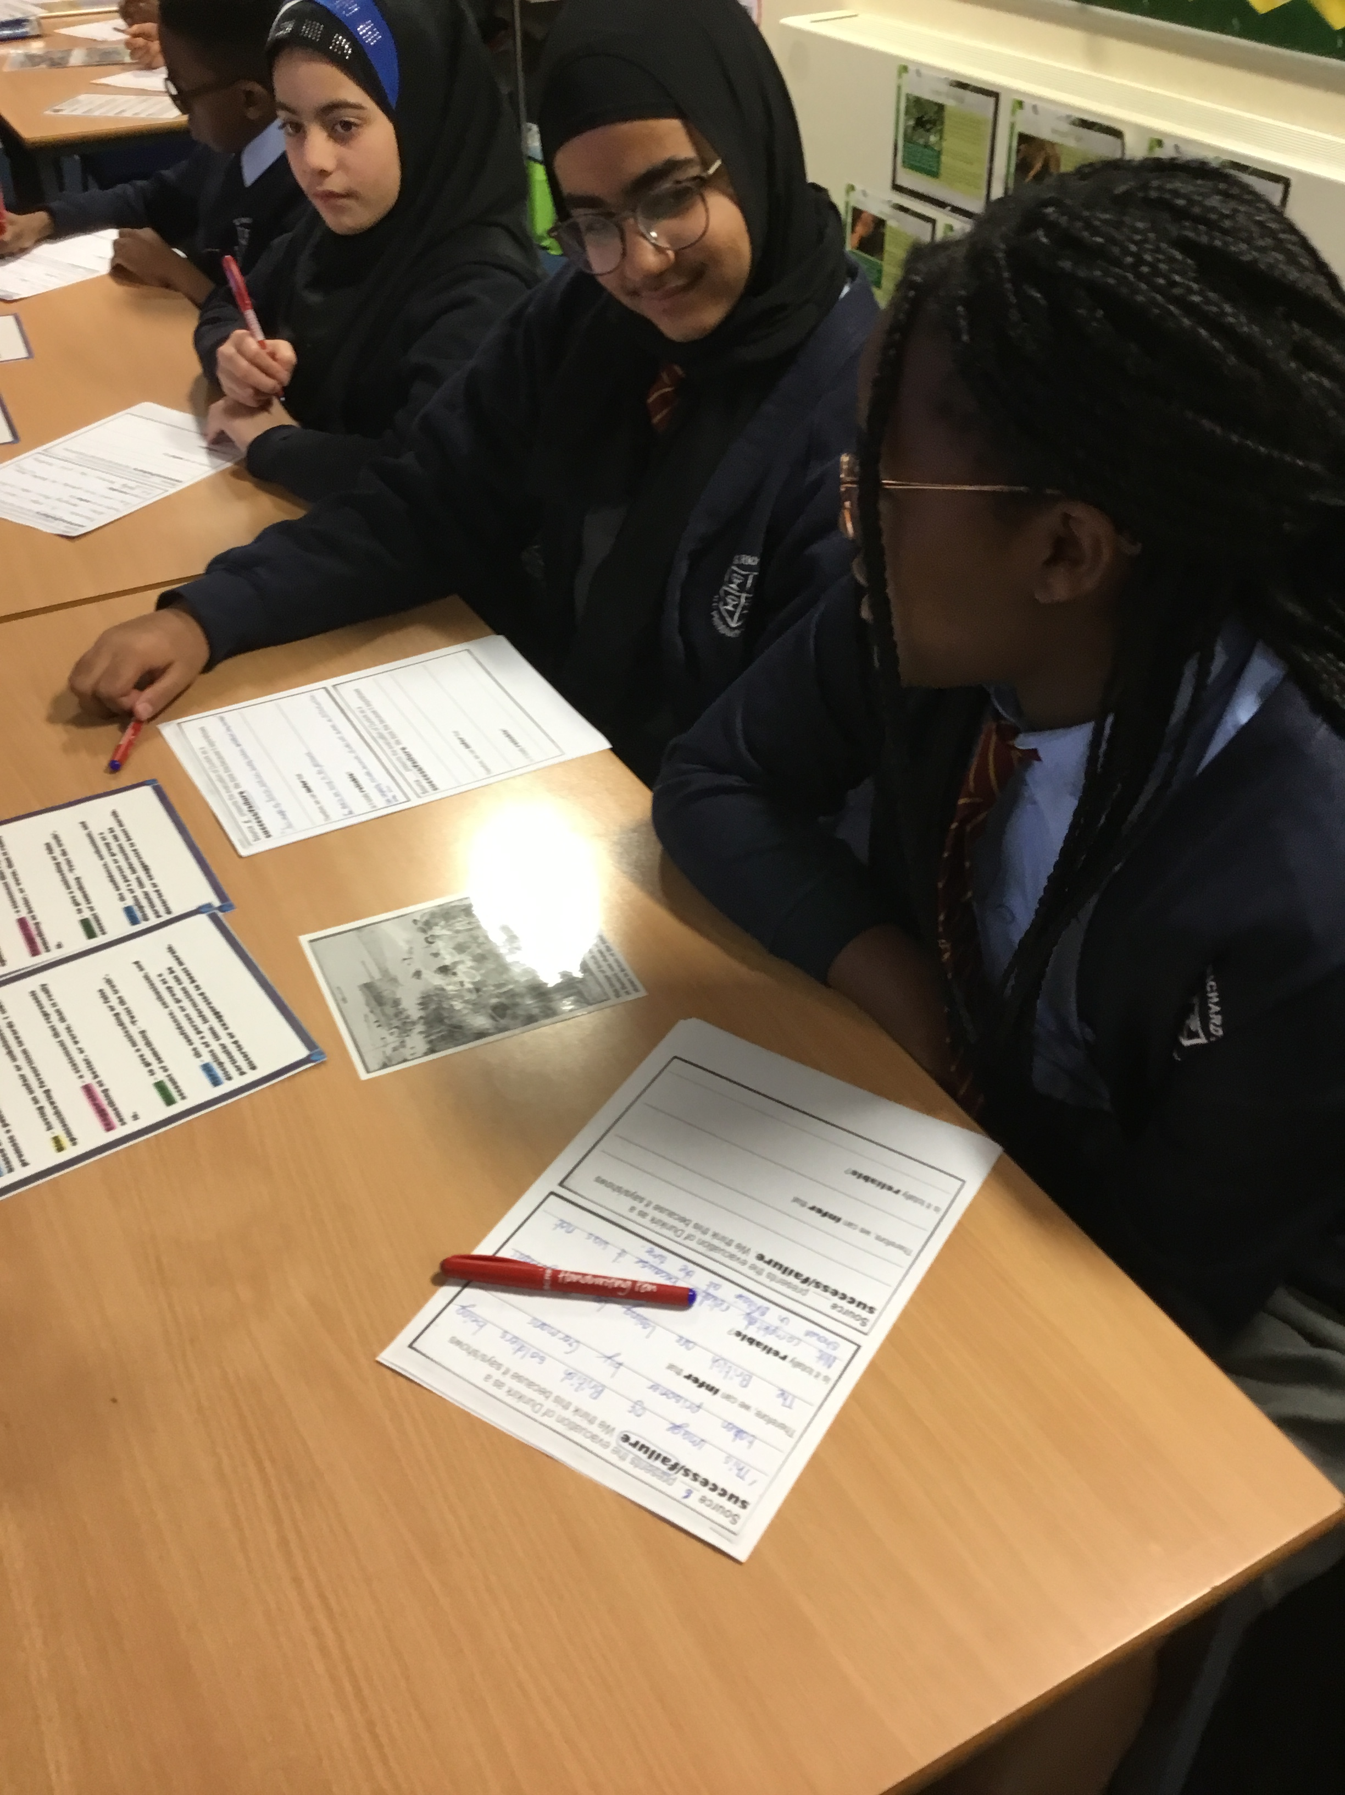

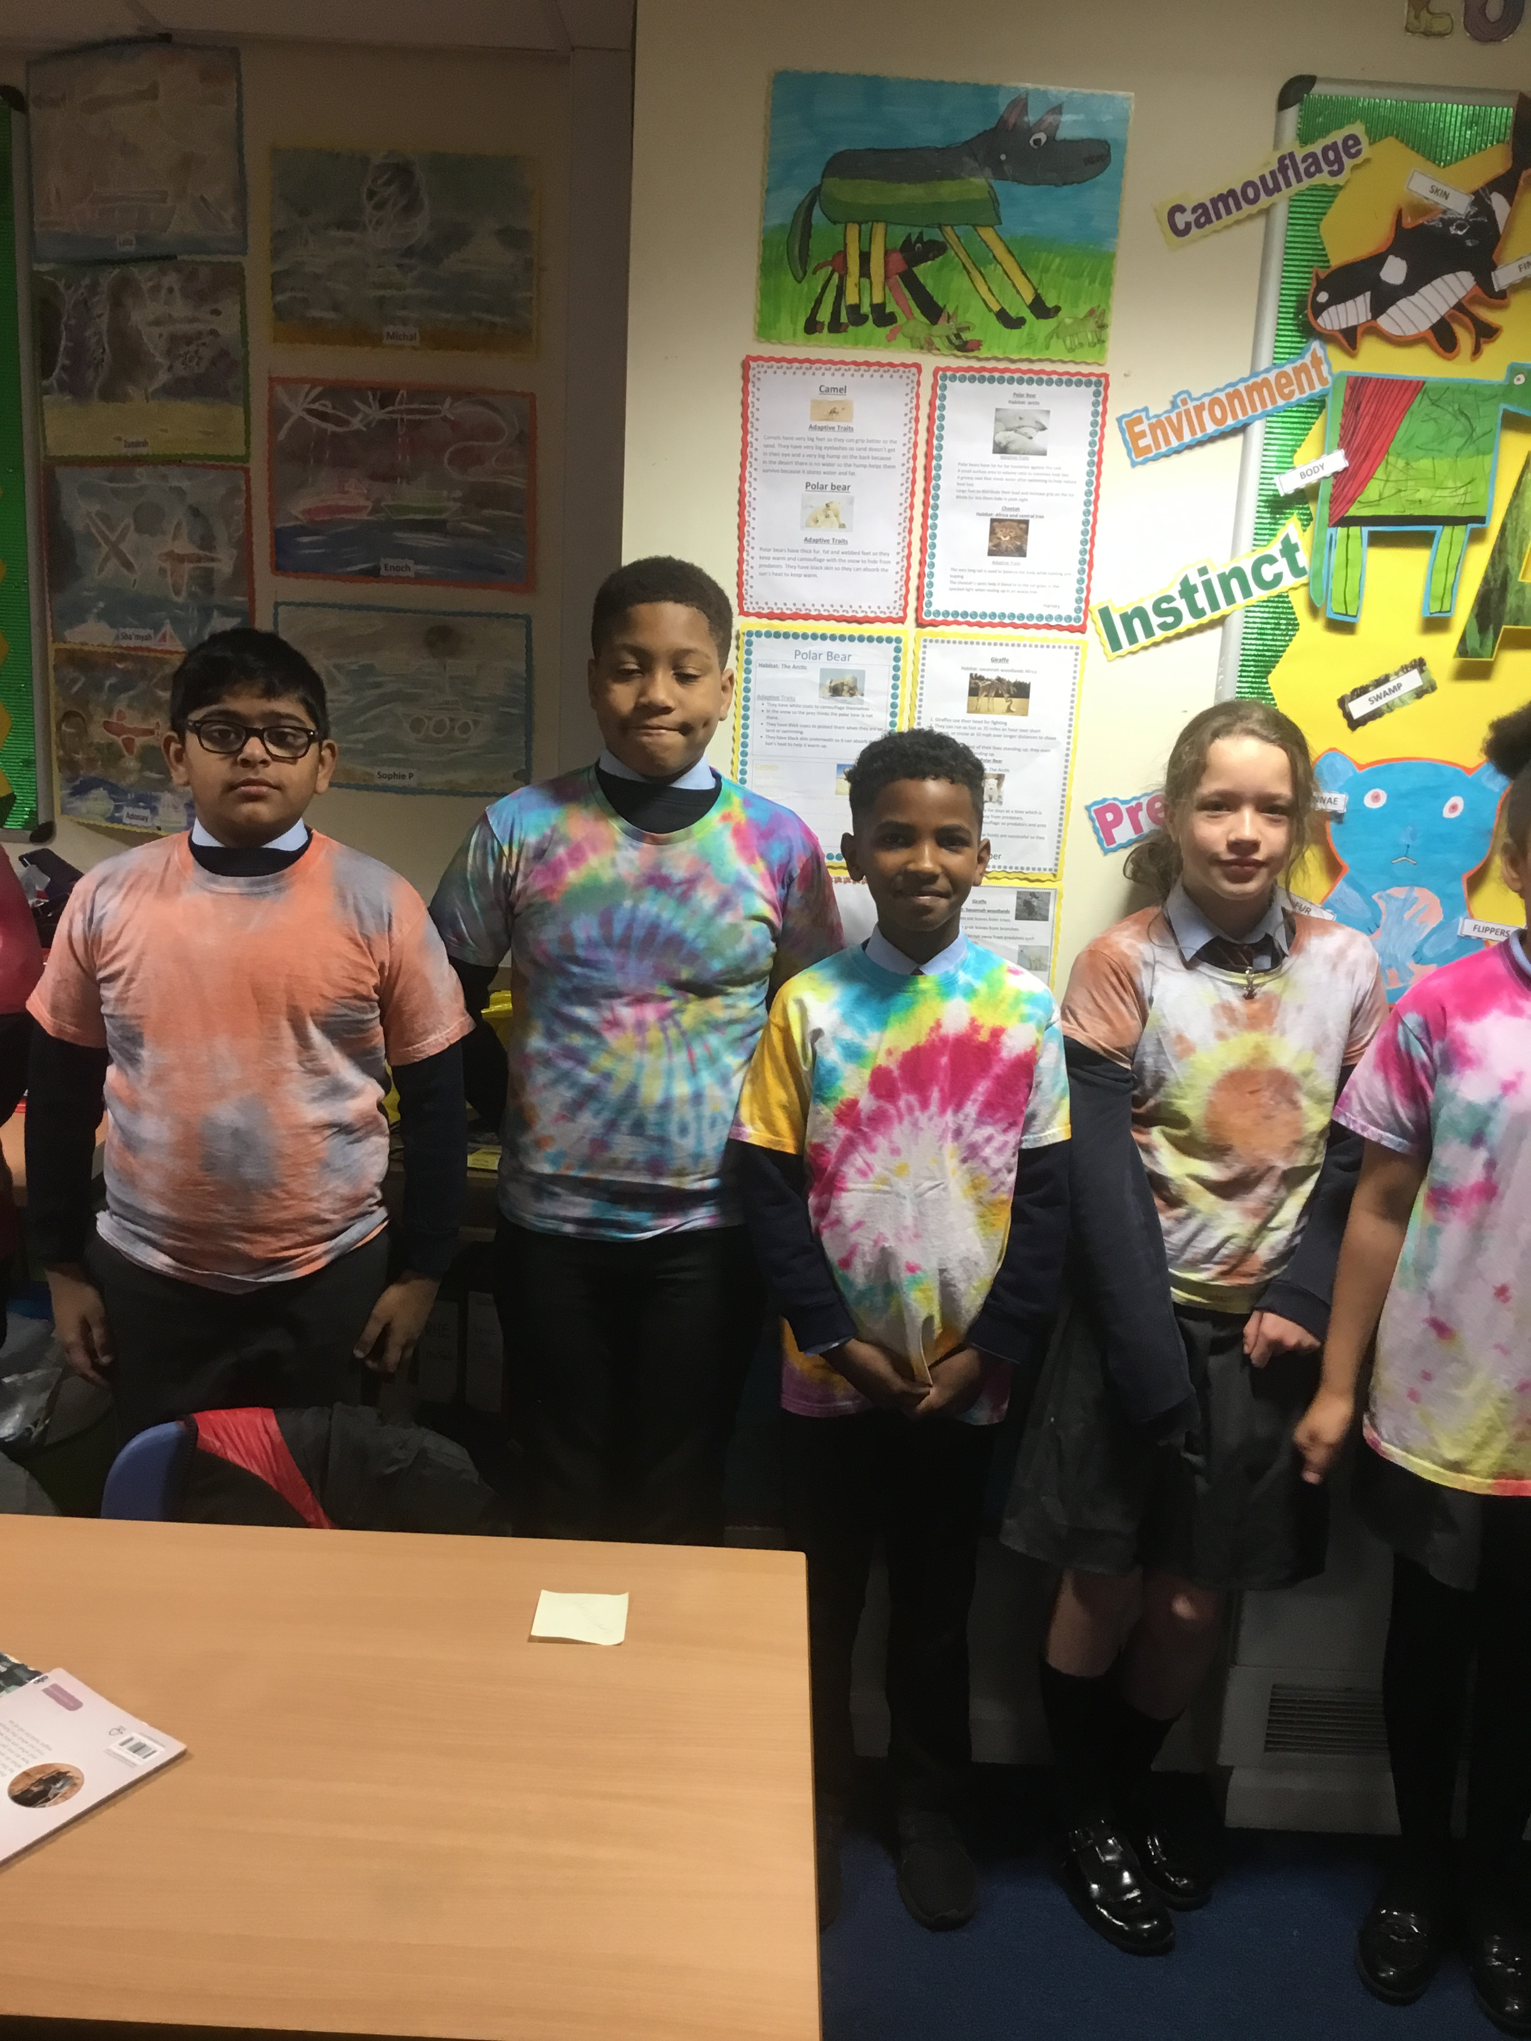

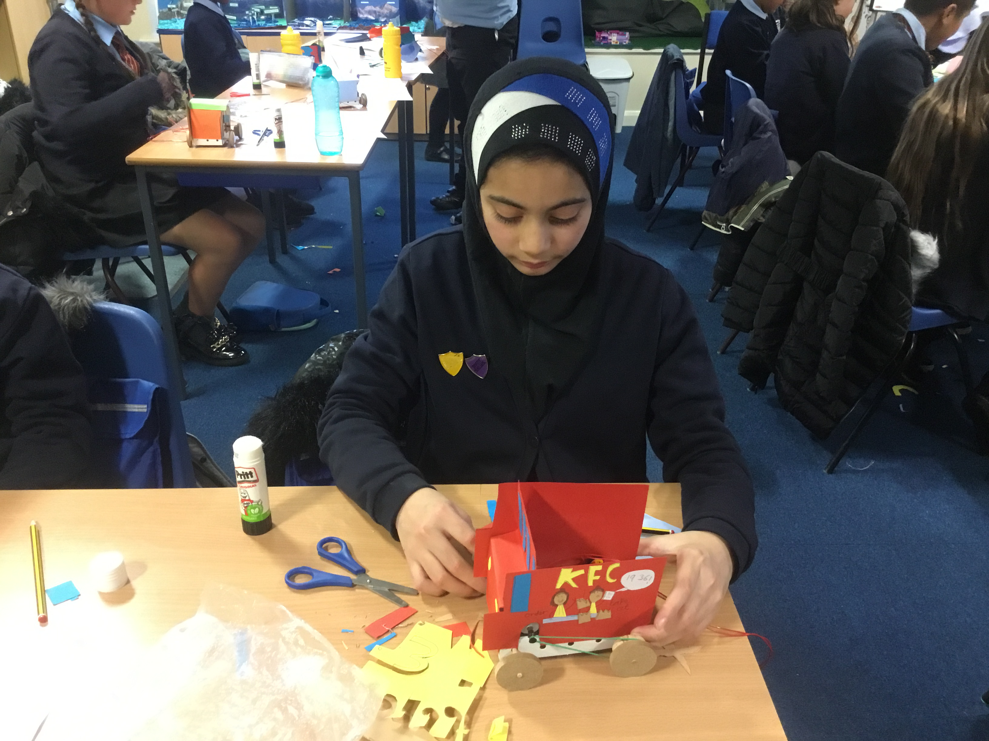

**Class 13**